ALUNO (A):

DATA DA PROVA: / / 2021
LISTA DE RECUPERAÇÃO – INGLÊS

SÉRIE: 6º ANO

TURMA: A 4º BIMESTRE

PROFESSOR (A): NATHAN
Nota:

Nº DE QUESTÕES:
15

- Preencha o cabeçalho de forma legível e completa.
- A interpretação das questões faz parte da avaliação.
- Certifique-se de que, em cada questão, todo o desenvolvimento e as operações estejam explícitos, o não cumprimento do item anulará a questão.
- Utilize somente caneta de tinta azul ou preta. Prova feita a lápis não será corrigida e não terá direito à revisão.
- Serão anuladas as avaliações em que forem constatados: termos pejorativos ou desenhos inadequados.
- Procure cuidar da boa apresentação de sua prova (organização, clareza, letra legível).
- As respostas com rasuras e/ou líquido corretor não serão revisadas e nem aceitas.
- Não é permitido ter celulares e/ou objetos eletrônicos junto ao corpo, sobre a carteira ou com fácil acesso ao aluno durante a realização da avaliação, sob pena de sua anulação.
- Em caso de “cola” a prova será anulada e zerada imediatamente pelo professor ou fiscal de sala.
INSTRUÇÕES

- What is the definition of Atmosphere?
- The envelope of gas that surrounds the planet.
- The envelope of oxygen that surrounds the planet.
- The envelope of nitrogen that surrounds the planet.
- The envelope of gas that surrounds the sun.

- What causes the “wind”?
- Differences in air preasure.
- Differences in altitude
- Differences in weather
- Differences in countries

- Circle the letter of the gas that is the largest component of the atmosphere.
- Oxygen
- water vapor
- nitrogen
- carbon dioxide

- What is density?
- The amount of mass in a given volume.
- The amount of air times the volume.
- The air above you going up through the atmosphere.
- The air around you.

- As you go up through the atmosphere, the density of the air decreases.
- True
- False

- What two instruments are commonly used to measure air pressure?
- Mercury and aneroid barometers.
- Scale
- Thermometer
- None

- The ozone layer is in the _____________ layer.
- Troposphere
- Stratosphere
- Mesosphere
- Thermosphere.

- What layer protect Earth from meteoroids?
- Troposphere
- Stratosphere
- Mesosphere
- Thermosphere.

- Which two conditions are required for cloud formation?
- Cool temperatures and the presence of particles
- Warm temperatures and the presence of particles
- High humidity and cool temperatures
- High humidity and warm temperatures

- Whatis a hurricane?
- A tropical cyclone with winds of 119km/h or higher.
- A tropical cyclone with winds of 70km/h.
- A polar cyclone with winds of 119km/h or higher.
- A polar cyclone with winds of 70km/h.

- What is precipitation?
________________________________________________________________________________________________________________________________________________________________________________________________________________________________________________________________________________________________________________________________________
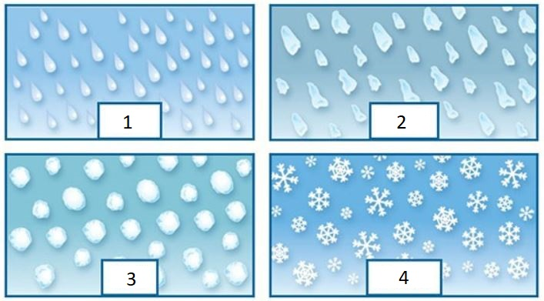

- Identify the types of precipitation.

1. | 2.
3. | 4.
- Classify the types of electromagnetic radiation in the picture.
- Complete the sentences using the words below:
Absorbed | Radiated | Reflected

- About 25 percent of incoming sunlight is ____________ by clouds, dust and gases in the atmosphere.
- About 50 percent is _____________ by Earth’s surface. This heats the land and the water.
- Some absorbed energy is _____________ back into the atmosphere.

- Identify each type of heat transfer in the picture.
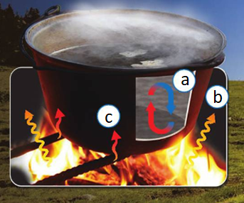
a)____________________
b)____________________
c)____________________

