ALUNO (A):

DATA DA PROVA: / / 2021
LISTA DE RECUPERAÇÃO – INGLÊS

SÉRIE: 9º ANO

TURMA: A 4º BIMESTRE

PROFESSOR (A): NATHAN
Nota:

Nº DE QUESTÕES:
14

- Preencha o cabeçalho de forma legível e completa.
- A interpretação das questões faz parte da avaliação.
- Certifique-se de que, em cada questão, todo o desenvolvimento e as operações estejam explícitos, o não cumprimento do item anulará a questão.
- Utilize somente caneta de tinta azul ou preta. Prova feita a lápis não será corrigida e não terá direito à revisão.
- Serão anuladas as avaliações em que forem constatados: termos pejorativos ou desenhos inadequados.
- Procure cuidar da boa apresentação de sua prova (organização, clareza, letra legível).
- As respostas com rasuras e/ou líquido corretor não serão revisadas e nem aceitas.
- Não é permitido ter celulares e/ou objetos eletrônicos junto ao corpo, sobre a carteira ou com fácil acesso ao aluno durante a realização da avaliação, sob pena de sua anulação.
- Em caso de “cola” a prova será anulada e zerada imediatamente pelo professor ou fiscal de sala.
INSTRUÇÕES

- What is ther mal energy?
- It is the total energy of all the particles in an object.
- It is the average of energy in the particles.
- It is the energy of motion.
- It is associated to the height.

- Complete the sentence “Heat is transferred from __________ areas to _________ areas.”
- Warmer/cooler
- Cooler/warmer
- Warmer/warmer
- Cooler/cooler

- Nuclear fusion reactions occur in ____________.
- The sun.
- Nuclear power plants.
- A microwave oven.
- A match that is struck.

- What is it?
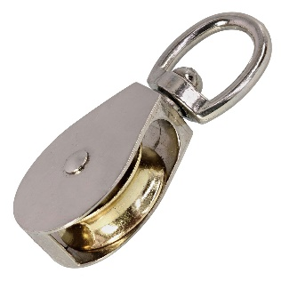
- Pulley
- Wheel
- Axle
- Flagpole

- Electromagnetic energy travels through space in the form of ____________.
- waves.
- molecules.
- particles.
- shape.

- A simple machine is…
- The most basic device for making work easier.
- The most complex device for making work harder.
- The most basic device for making work harder.
- The most complex device for making work easier.

- What is Efficiency?
- It’s a comparison of the energy output to the energy input in a given system.
- It’s the energy transferred to or from an object via the application of force along a displacement.
- The force you put on the machine.
- The force the machine exerts on an object.

- Real machines have an efficiency of less than 100% because some work is wasted to overcome _____________.
- Friction.
- Gravity.
- Weight.
- Pulling.

- The sun transfer heat by _________________.
- Radiation
- Conduction
- Convection
- None.

- What is a conductor material?
- A material that conducts heat well.
- A material that conducts heat bad.
- A material that conducts heat very bad.
- A material that doesn’t conduct heat well.

- What are input force and output force?
______________________________________________________________________________________________________________________________________________________________________________________________________________________________________________________
- What is energy?
______________________________________________________________________________________________________________________________________________________________________________________________________________________________________________________
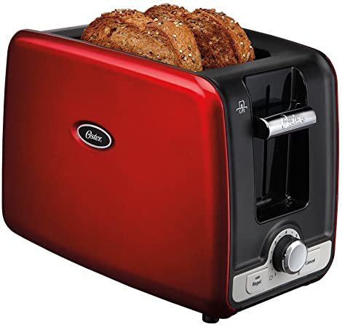
What kind of transformation does a toaster do? Explain the process.
________________________________________________________________________________________________________________________________________________________________________________________________________________________________________________________________________________________________________________________________________
- What is the law of conservation of energy?
________________________________________________________________________________________________________________________________________________________________________________________________________________________________________________________________________________________________________________________________________
- What are the ‘types of charge’ and how do they interact?
________________________________________________________________________________________________________________________________________________________________________________________________________________________________________________________________________________________________________________________________________

