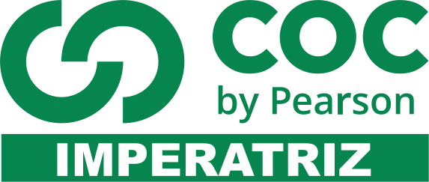
ALUNO (A):

DATA DA PROVA: / / 2021
LISTA DE RECUPERAÇÃO – INGLÊS

SÉRIE: 7º ANO

TURMA: A 4º BIMESTRE

PROFESSOR (A): MAYARA
Nota:

Nº DE QUESTÕES:
14

- Preencha o cabeçalho de forma legível e completa.
- A interpretação das questões faz parte da avaliação.
- Certifique-se de que, em cada questão, todo o desenvolvimento e as operações estejam explícitos, o não cumprimento do item anulará a questão.
- Utilize somente caneta de tinta azul ou preta. Prova feita a lápis não será corrigida e não terá direito à revisão.
- Serão anuladas as avaliações em que forem constatados: termos pejorativos ou desenhos inadequados.
- Procure cuidar da boa apresentação de sua prova (organização, clareza, letra legível).
- As respostas com rasuras e/ou líquido corretor não serão revisadas e nem aceitas.
- Não é permitido ter celulares e/ou objetos eletrônicos junto ao corpo, sobre a carteira ou com fácil acesso ao aluno durante a realização da avaliação, sob pena de sua anulação.
- Em caso de “cola” a prova será anulada e zerada imediatamente pelo professor ou fiscal de sala.
INSTRUÇÕES

Resources and Living Things
Multiple Choice
Write the letter of the correct answer on the line at the left.
______ 1. Which of the following is considered a renewable resource?
a. iron c. oil
b. sunlight d. coal
______ 2. The study of natural processes in the environment and how humans can
affect them is called
a. resource management. c. preservation.
b. environmental science. d. conservation.
______ 3. An area with a large population of valuable ocean organisms is called a(n)
a. aquaculture. c. fishery.
b. sustainable yield. d. neritic zone.
______ 4. Cutting down only some trees in a forest, leaving a mix of tree sizes and species standing, is called
a. selective cutting. c. certified cutting.
b. clear-cutting. d. patch cutting.
______ 5. The number of different species in an area is referred to as its
a. niche diversity. c. habitat fragmentation.
b. climate. d. biodiversity.
______ 6. If all members of a species disappear from Earth, the species is said to be
a. extinct. c. threatened.
b. endangered. d. keystone.
______ 7. The mating of California condors in zoos is an example of
a. habitat preservation. c. biodiversity.
b. captive breeding. d. habitat destruction.
Resources and Living Things (continued)
______ 8. The loss of a natural habitat is called
a. habitat destruction. c. pollution.
b. habitat fragmentation. d. poaching.
______ 9. All of the following factors affect an area’s biodiversity except
a. area. c. climate.
b. number of endangered species. d. diversity of niches.
______ 10. If fish are caught faster than they can breed, the population will
a. increase. c. remain the same.
b. decrease. d. move to other waters.

Land, Air, and Water Resources
Chapter Test A
Multiple Choice
Write the letter of the correct answer on the line at the left.
______ 1. Upwelling carries nutrients out of what kind of ocean waters?
a. dark c. deep
b. shallow d. clean
______ 2. The process of restoring an area of land to a more natural, productive state is called
a. erosion. c. desertification.
b. nutrient depletion. d. land reclamation.
______ 3. A type of landfill designed to hold municipal solid waste safely is
a. a compost pile. c. a leachate landfill.
b. a sanitary landfill. d. an open dump.
______ 4. To create less waste in the first place is to
a. reduce. c. recycle.
b. reuse. d. incinerate.
______ 5. Which type of hazardous waste gives off radiation?
a. toxic waste c. flammable waste
b. corrosive waste d. radioactive waste

______ 6. Most of Earth’s water (about 97 percent) is
a. freshwater in lakes and rivers. c. in the form of snow or ice.
b. salt water in the oceans. d. in the clouds.

True or False
If the statement is true, write true. If it is false, change the underlined word or words to make the statement true.
____________ 16. Water, fuels, and minerals are nonliving ocean resources.
____________ 17. Bacteria break down wastes during secondary treatment of wastewater.
____________ 18. The water and human wastes that are washed down sinks, toilets, and
showers are called sewage.
____________ 19. Ocean resources around the world are equally distributed.
____________ 20. A type of land use called mining involves the removal of nonrenewable
resources from the land.

