ALUNO (A):

LISTA DE RECUPERAÇÃO- INGLÊS

SÉRIE: 8º ANO

4º BIMESTRE

Nota:

Nº DE QUESTÕES:
09

1) Fill in the gaps with the Past Continuous of the verbs in brackets.
- The teacher __________ (not talk) when Mary arrived.
- The pupils __________(play) when the bell rang.
- Lucy __________ (do) her homework when someone knocked the door.
- Mark´s parents __________(write) him a letter when they heard a crash.

2) Write sentences in the negative and affirmative:
Example: Mary / not draw / in class / (read)
Mary wasn´t drawing in class. She was reading.
- The children / not play/ on the beach / (swim)
- _________________________________________________
- You / not listen to me / (talk)
- _________________________________________________
- My parents / not watch TV / (work)
- _________________________________________________
- Ann / not laugh / (cry)
- _________________________________________________
- My sister / not sleep / ( study)
- ________________________________________________
- I / not eat / (drink)
- ________________________________________________

3) Match the dialogues with the pictures.

  - A: Were the students doing research for a school project?
B: Yes, they were.
  - A: Were the students having lunch?
B: No, they weren’t. They were taking a test.
  - A: Was Felipe writing an e-mail?
B: Yes, he was.
  - A: Was Julia taking a shower?
B: No, she wasn’t. She was chatting with a friend.

4) Look at the pictures of health problems and write their name.
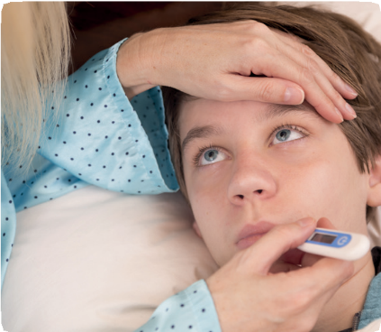

_____________________ ___________________

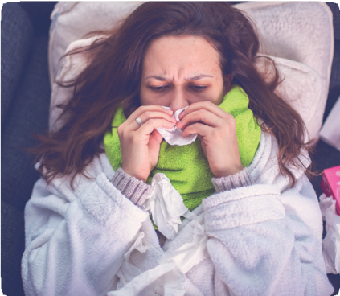

5) Give advice to these people using SHOULD or SHOULDN’T and the phrases in the box.
to see a dentist to sleep late to drink tea with honey to study harder

a) A: What’s the matter?
B: I have a sore throat.
A: ____________________________________

- A: What’s the matter?
B: I have a very difficult test next week and I need a good grade.
A: ________________________________
b) A: What’s the matter?
B: I have a toothache.
A: __________________________
.
- A: What’s the matter?
B: I have to wake up at 5:30 a.m. tomorrow.
A: ________________________________

6) Complete the sentences with the verbs + ING.

- My father was _____________ dinner. (cook)
- Luiza was ______________ a shower. (take)
- Fernando was ___________ the newspaper. (read)
- We were _____________ to music. (listen)
7) Complete the words for health problems with vowels.
- F __ V __ R
- C __ L D
- H __ __ D __ C H __
- P __ __ N
8) Put this verb in to Gerund.

- Read _________________
- Take _________________
- Swim _________________
- Cook __________________

9) Read and answer the questions.
Gustavo: Hey, Patricia. What’s the matter?
Patricia: I’m not feeling well. I have a terrible headache and I think I have fever, too.
Gustavo: Oh no! You should go to the doctor.
Patricia: Can you tell our science teacher that I’m not feeling well?
Gustavo: Sure! I’ll tell her. Don’t worry.

Patricia: Thanks. I’ll ask the school secretary to call my mom.
Gustavo: I’ll go there with you. Let’s go.
Patricia: Oh, and can you text me about homework?
Gustavo: Sure! I’ll send you a message if there is any homework.
Patricia: OK!
Gustavo: I hope you feel better. Patricia: Thank you. See you tomorrow. Gustavo: See you.

  - What’s the matter with Patricia? __________________________________________
  - Is she staying at school for science class? ___________________________________
  - Who is going to call Patricia’s mom? ________________________________________
  - How is she going to know if there is homework? __________________________________

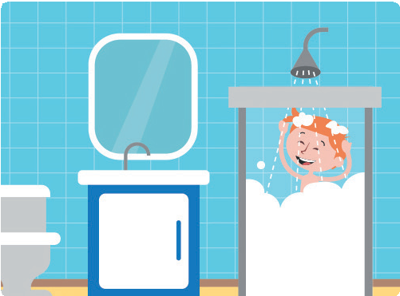
9) Match the pictures with the actions.

  - c.

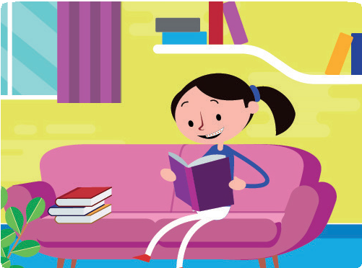
  - d.
e.

____ to study
____ to organize the closet
____ to watch TV
____ to read
____ to take a shower

¢

Name:
Date: Grade:

Match the questions with the answers. (1 mark)
  - Where did you stay for your vacation?
  - What did you buy at the mall?
  - Why did you wake up early?
  - How did you go to school?
  - When did you talk to Emily?

Circle the correct alternative. (1 mark)
  - A: did your mother go?
B: She went to the supermarket.
a. Where
  - When

I bought a T-shirt and a book. I went to school by bus.
I stayed at a nice hotel.
b d a e
c
I talked to her last night. Because I had to go to school.

- A: did you and Bruno go to the mall yesterday?
Bimestrial Test
rewınd ¢
C
New iLearn 3
PRINTABLE - ILEARN NEW © Pearson Education do Brasil, 2018
B: We went by subway.
b. How
a. Who
- A: did your father travel to Argentina?
B: He traveled last month.
b. When
a. What
- A: did you buy for your sister’s birthday?
B: I bought a pair of shoes.
a. What
b. Why

Write affirmative or negative x answers. (1 mark)
a. Were you having dinner?
Yes, I was.
b.
Were Antonia and Larissa studying English? x
No, they weren’t.
Was Patrick playing a board game? x
c.
No, he wasn’t.
Were your parents working?
d.
Yes, they were.

31

Look at the list of actions and complete the questions and answers. (1 mark)

YESTERDAY…
 | LETICIA | MURILO
at 9:00 a.m.  at 11:30 a.m.  at 7:00 p.m. | chatting with friends listening to music playing with the dog | drinking lemonade eating a sandwich watching a movie

  - What was Leticia doing at 11:30 a.m.? She was listening to music .

  - Was

Leticia

chatting with friends at 9:00 a.m.?

Yes, she was.
  - Was Murilo eating a sandwich at 7:00 p.m.?
No, he wasn’t.

  - Who was Murilo.

watching

a movie at 7:00 p.m.?

Complete the sentences using the Past Continuous and the Simple Past. (1 mark)
  - The students were taking a test when the bell rang .(to take / to ring)
  - I was chatting with a friend when you called me. (to chat / to call)
  - She was rollerblading when she fell down . (to rollerblade / to fall down)
  - While she was reading a book, she fell asleep . (to read / to fall asleep)

Unscramble the letters and guess the name of some health problems. (1 mark)

  - E H C A D A E H
  - T H A C H E T O O
  - O R S E R O A T H T

HEADACHE TOOTHACHE SORE THROAT

  - V R E E F FEVER

  - L O D C

COLD

Match the requests with the correct reply. (1 mark)
  - Could you close the window, please?
f a e c b
d
  - Can you bring me a box of cereal, please?
  - Can you give her a message, please?
  - Could you give me a ride?
  - Can you lend me your umbrella?
  - Can you lend me an eraser?

Sure! Here you are. Would you like a pencil, too? Sure. No problem. It’s cold here.
Sorry, I can’t. It’s broken.
Sure. What would you like me to tell her?
Sure. Would you like the big box or the small box? Sorry, I can’t. I’m going by bus.

PRINTABLE - ILEARN NEW © Pearson Education do Brasil, 2018

2

- Use the prompts to give advice to these people using should or shouldn’t. (1 mark)
  - I have a terrible toothache. (to see a dentist)
You should see a dentist.

  - I have a pain in my leg. (not to go to the gym today)
You shouldn’t go to the gym today.

  - I am late for work. (to take a taxi)
You should take a taxi.
  - I have a sore throat (not to talk much)
You shouldn’t talk much.

Imagine you are sick at home. A friend is visiting you. What favors can you ask him/her to do for you? Write your ideas below. (1 mark)
Answers will vary.

Read and match the people with the actions. (1 mark)

5 minutes ago @patrick and @gabriel are playing online games.
BELLA’S BLOG

2 hours ago I am drinking a lot of water! I’m tired aker the sports practice.

@bella
I am friendly Bella

12 hours ago My sister is taking an important test at school.

1 day ago My cousins @oliver and @bruna are traveling to Australia. Wow!

4 days ago Vivian is feeling sick .I hope she gets better soon. We have a party on Saturday.

  - Vivian was...
  - Oliver and Bruna were...
  - I was...
  - Patrick and Gabriel were...
  - My sister was...

playing online games.
taking an important test at school. traveling to Australia.
d e b c
a
drinking water and feeling tired. feeling sick.

PRINTABLE - ILEARN NEW © Pearson Education do Brasil, 2018

3

