ALUNO (A):

DATA: / / 2019
LISTA DE RECUPERAÇÃO- INGLÊS

SÉRIE: 7º ANO

4º BIMESTRE

PROFESSOR (A): ALESSANDRA GOMES
Nota:

Nº DE QUESTÕES:
07

1. Write the food items in the correct column

Ketchup water potatoes milk tomatoes
hot dog buns cheese onion

FOOD YOU CAN COUNT | FOOD YOU CAN’T COUNT

2. Complete the questions with how much or how many.
a) ________________ tomatoes do we need to buy?
b) ________________ cans of soda are there?
c) ___________________ milk do we need?
d) __________________ eggs are there?
e) ___________________ potatoes are there?
f) _____________________ water is there? There are 3 litres.
g) _____________________ money is there in your pocket?
h) _____________________ carrots are there for the salad?
i) ______________________ loaves of bread are there?

3. Complete the sentences with some or any.

a) Are there ______ eggs?
b) There aren’t ________ tomatoes.
c) Is there ________ meat? Yes, there is.
d) There aren’t _________ apples.
e) There is _________ milk.
f) Are there ______ bottles? Yes, there are.
g) There isn’t _________ fish.
h) Are there _________ potatoes? No, there aren’t.
i) There is _______ butter.
j) There is some ham.
k) Are there _______ jam jars? Yes, there are.
l) There aren’t __________ carrots.

4. Read and check ( X ) the items João’s mother has to buy.

Mom,
Remember my friends are coming tomorrow to spend some time with me. Please buy some sausages. I want to make hot dogs. You don’t have to buy the hot dog buns. We have some left here. Can you buy some cans of soda too? I guess six is enough. What can we have for dessert? How about some cupcakes? I can make some. We have all the ingredients here. I guess that’s all.

Thanks!
João

soda ( ) sausages ( ) hot dog buns ( ) cupcakes ( )

5. Match the pictures with the words.
_________
of orange juice

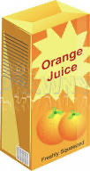

6. Complete with the vowels to form the name of some food items.
________
of potato chips

________
of soda

________
of water

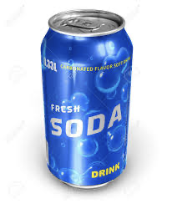

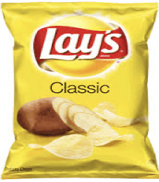

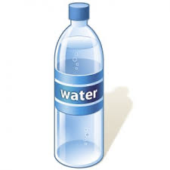

- S __ U S A G __ S
- J __ I C __
- T __ M __ T O __ S
- S __ D __

