ALUNO (A):

DATA: / / 2019
LISTA DE RECUPERAÇÃO- INGLÊS

SÉRIE: 6º ANO

4º BIMESTRE

PROFESSOR (A): ALESSANDRA GOMES
Nota:

Nº DE QUESTÕES:
07

- Look at the pictures and write the school activities.

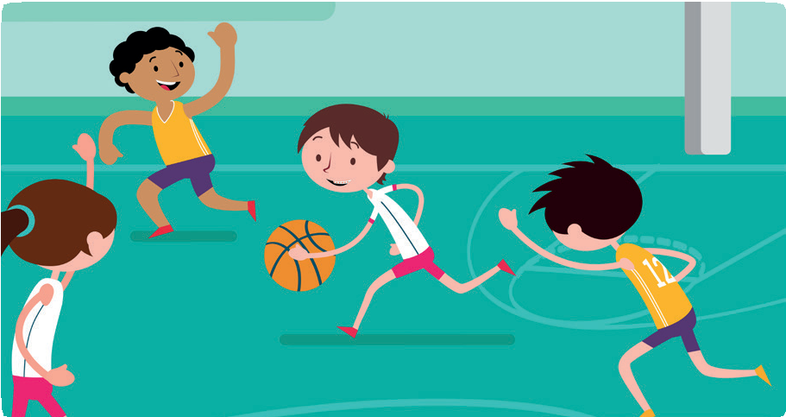
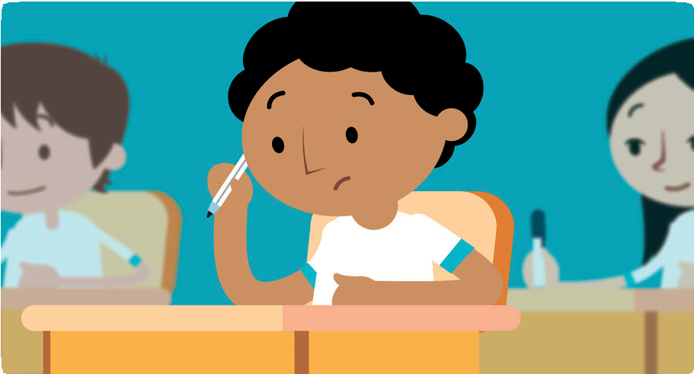

nit 8

2. Complete the sentences with the verbs in the box in the Present Continuous.

  - Mateus and Beatriz a robotic seminar.
  - You lunch now.
  - Jonatan for a test.
  - I a book at the reading club.
  - Lorena basketball.
  - We in a choir.

3. Use the prompts to write sentences. Use the negative and affirmative form of the Present Continuous.
  - Clara and Lucy – not eat hamburgers – eat pizza

____________________________________________________________
  - Beth – not read a book – surf the Internet

____________________________________________________________
  - Tony – not play basketball – play soccer

____________________________________________________________
  - Diego – not cook – watch TV

____________________________________________________________

4. Match the questions with the answers.
  - Is he having a drama class now?
  - Are you studying for a test?
  - Is Lisa reading a book?
  - Are the boys attending the robotic seminar?

_____Yes, they are. They are at Tech Week.
_____Yes, he is. He is having a class at the theater.
______Yes, I am. The math test is tomorrow.
______No, she isn’t. She is watching a video.

5. Complete these sentences. Use can or can’t + one of these verbs:
Come - find - hear - see - speak
I’m sorry but we ____________________to your party next Saturday.
I like this hotel room. You ____________________ the mountains from the window.
You are speaking very quietly. I ____________________you.
Have you seen my bag? I ________________________it.
Catherine got the job because she ________________________ five languages.
6. Complete the sentence with can and can’t.
A cat ___________________ climb a tree, but it ________________fly.
A fish __________________ walk, but it _____________________swim.
A dog ___________________ bark, but it ______________________sing.
You ____________________ buy shoe at the post office, but you ___________ buy stamps.
A tiny baby ________________ cry, but it ______________________ talk.
I _________________ write with a pen, but I __________________ write with a paper clip.
Fish __________________ live in air, but they ___________________ live in the water.
You __________________ store water in a glass jar, but you _________________ store it in a paper bag.
You ___________________ ride on the back of the cat, but you _______________ ride on the back of a horse.

7. Write a list of the things you can and can’t do. ____________________________________________________________ ____________________________________________________________ ____________________________________________________________ ____________________________________________________________ _____________________________________________________________ _____________________________________________________________

