ALUNO (A):

DATA: / / 2019
LISTA DE RECUPERAÇÃO- INGLÊS

SÉRIE: 7º ANO

3º BIMESTRE

PROFESSOR (A): ALESSANDRA
Nota:

Nº DE QUESTÕES:
10

1.Unscramble the letters and find the names of hair colors.

a. A Y R G. ___________________

b. C A B K L. ___________________

c. D E R. ___________________

d. D L B N O. ___________________

e. W O R N B. ___________________

2. Write the words in the correct place.

tall - brown - curly - blue - long - gray - chubby blond - medium length - wavy

HAIR LENGTH _____________, _____________
HAIR STYLE _____________, _____________
HAIR COLOR _____________, _____________
EYE COLOR _____________, _____________
BODY _____________, _____________

3. Look at the pictures of body build and write their names.

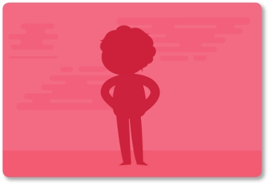

___________________ ______________

___________________ ___________________

4. Unscramble each of the clue words. Then copy the letters in the numbered cells to other cells with the same number.

G E N E R ___ ___ ___ ___ ___
12 14

K A D R B N R O W ___ ___ ___ ___ ___ ___ ___ ___ ___
11 3 13

R A D K ___ ___ ___ ___
6

L E B U ___ ___ ___ ___
4 10 7 2

H I L G T B O R N W ___ ___ ___ ___ ___ ___ ___ ___ ___ __
9 1 8

___ ___ ___ ___ S ___. ___ ___ ___. ___ ___ F ____ ____ ____ ____ ____ _____ ____ Y ____
1 2 1 3 4 2. 6. 7. 8. 9. 7 10 11. 6. 12. 13 14. 14

5. Read and circle F (false) or T (true).
Hi everyone! My name is Anna. I’m 13 years old. There are many activities I like to do afer school. I always play sports on Wednesdays and Fridays, but I never play soccer. I don’t like it. I prefer volleyball and basketball. I sometimes read a book and I ofen listen to music. On Saturdays I always play board games with my cousins. On Sundays, I play video games. My favorite kinds of video games are adventure and RPG.

- She plays sports on Wednesdays and Fridays. T F
- She plays soccer? T F
- She plays board games with her cousins. T F
- She likes adventure and RPG. T F

6. Complete the adjectives with the missing letters

- M __ O D __
- L __ Z __
- F R I __ N D L __
- N __ C __
- S T U __ B O R __

7. Write the words under the correct category.

nice rude stubborn moody easy-going friendly intelligent lazy
POSITIVE CHARACTERISTICS NEGATIVE CHARACTERISTICS

8. Match the descriptions with the pictures.

- This avatar has long, curly, brown hair.
- b. This avatar has short, straight, light brown hair and wears glasses.
- c. This avatar has short, straight, red hair.
- d. This avatar has long, straight, blond hair.

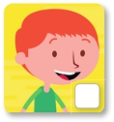
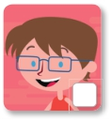
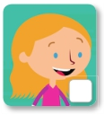
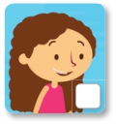

9. Answer the questions about yourself

a. What do you look like? ________________________________________

b. Are you tall? ________________________________________

c. What color is your hair? ________________________________________

d. Is your best friend nice and easy-going? _____________________________________

10. Write the words for hair features.



 

