ALUNO (A):

DATA: / / 2019
LISTA DE RECUPERAÇÃO- INGLÊS

SÉRIE: 6º ANO

3º BIMESTRE

PROFESSOR (A): ALESSANDRA
Nota:

Nº DE QUESTÕES:
09

- Complete the questions with this or that.

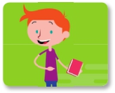

What is _____ ?
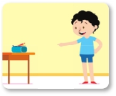
________ is a notebook.

What is ______ ?
_____ is a pencil case.
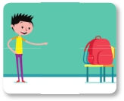

What is ______ ?
_____ is a backpack.

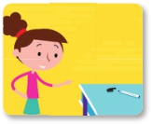

What is ______ ?
_____ is a pen.

2. Read the information in the table and complete the sentences

ITEM QUANTITY NOTE
Pen 4 2 blue, 1 red, 1 black
Pencil 4
Pencil case 1 big, any color
Notebook 4 Thick
Backpack 1 blue, big
Eraser 2 white
Colored pencil 24

- The students need two white _______________.
- The students need one big ______________ of any color.
- The students need four thick _______________.
- The students need two blue _________________.

3. Answer the questions about your school supplies.

a. What color is your backpack? ______________________

b. Is your backpack heavy? _____________________

c. Are your notebooks small ? _____________________

d. Is your pencil case big? _____________________

4. Name the clothes and accessories.

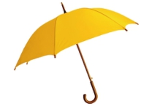

_______________

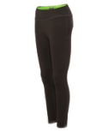

_________________

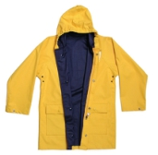

________________

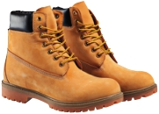

_________________

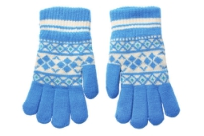

_________________

5. Look at the pictures and circle the correct alternatives

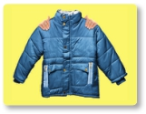

Is _____ your jacket? A) this. B) that

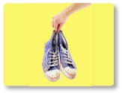
Are _____ your shoes? A) those B) these

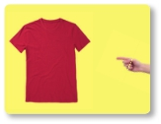

Is _____ your T-shirt? A) that B) this

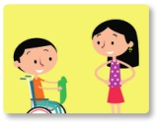

Is _____ my T-shirt? A) that B) this

6. Unscramble the letters to find the names of school supplies.

- B E T O N K O O ________________________
- R E L U R ______________________
- R A S E R E _____________________
- I O N T Y R A C I D ____________________

7. Unscramble the sentences.

a. a / book / red / it’s _________________________

b. blue and white / are / they / notebooks. _________________________

c. book / it’s / a / green. _________________________

d. they / pencil cases / are / pink and red. _________________________

8. Read and circle T (true) or F (false).

Mateo: Dad, I need to buy my school supplies.
Dad: All right. Let’s see…What do you need?
Mateo: I need a ruler.
Dad: What color?
Mateo: I like the yellow ruler.
Dad: Your pencil case is too old. You need a new one, too.
Mateo: OK. I want the red pencil case.
Dad: Great! And here are your new books
and the dictionary.
Mateo: But dad, they are too heavy.

- Mateo needs to visit school. T F
- He needs a pencil sharpener. T F
- His pencil case is too old. T F
- He wants the red ruler. T F
- His books aren’t heavy. T F

9. Match the questions with the answers.

a. How much are the gloves? (__) No, it isn’t. It’s $8.
b. Is the umbrella expensive? (__) The yellow sweater is $38.
c. How much is the shirt? (__) They’re $25.
d. How much is the sweater? (__) The shirt is cheap. It’s $15.

