ALUNO (A):

DATA: / / 2019
LISTA DE EXERCÍCIO-INGLÊS

SÉRIE: 6º ANO

2º BIMESTRE

PROFESSOR (A): MARIA GABRIELLA
Nota:

1. Read the dialogue and Choose the correct alternative.
- ____________ this your pencil?
- No, it ____________.

a) IS\ARE
b) IS\ISN’T
c) ISN'T\ISN’T
d) ARE\IS

2. What’s the correct order of the conversation?

( ) What is her name?
( ) Her name is Cintia.
( ) Hi Jane. Who is this?
( ) This is my sister.

A) 1,2,3,4
B) 3,4,1,2
C)1,2,4,3
D)4,3,2,1

3. Look at the picture and answer: What type of text is it?
a)It’s a song.
b)It’s an article.
c)It’s a comic.
d)It’s a story.

4. Read the comic strip.

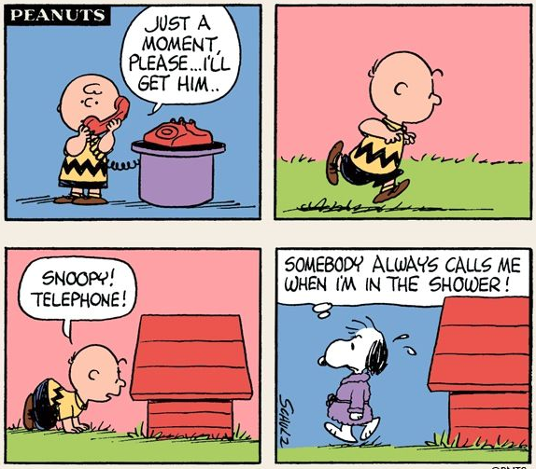
a) Analise o texto e explique porque a tirinha é engraçada:
______________________________________________________________________________________________________________________________________________________

5. Ao observar a imagem acima, retirada de um dicionário bilíngue, é correto afirmar que:
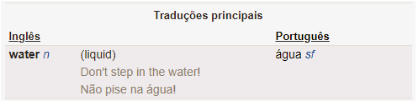
a)o dicionário bilíngue mostra palavras parecidas.
b)o dicionário bilíngue faz a tradução das palavras.
c)o dicionário bilíngue explica a origem das palavras.
d)o dicionário bilíngue está escrito somente em português.

6. Marque os adjetivos na forma contraída:
A)You’is pretty
B)You’re beautiful
c)You are
D)We is

7. Complete with am, is or are.

a) Fernanda ______ my sister.
b) Douglas ______ my father.
c) Bobby and Vanessa _____ my friends.

8. Complete the dialogue.
MOTHER'S NAME SISTER BROTHER FAMILY

This is my ___________. My name is Lucy, and I have a _____________ and a ___________.
My ___________ name is Mag and my father's ___________ is Bobby

9. Complete the dialogue with the words.
AM MIKE HI!

__________! My name is __________.
Hello Nick, I __________ Lucas.

10. Choose the correct alternative.

My name is Catherine. I _____________ a ______________.

A) AM; MUSIC B) AM; TEACHER

11. Put the dialogue in the correct order.

( ) I'M OK AND YOU?
( ) HI, MONICA! HOW ARE YOU?
( ) I'M OK TOO.

12. Look at the picture and write T- true or F – false:

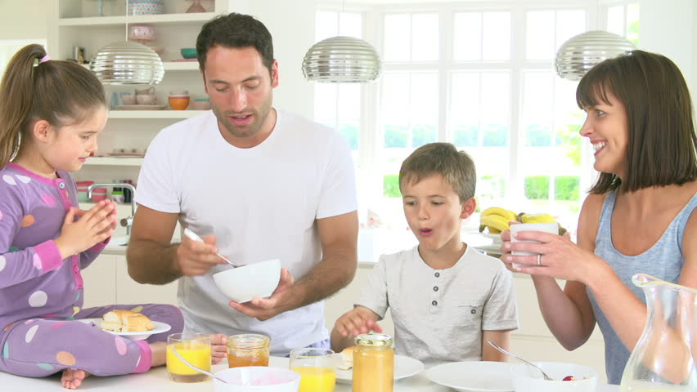

1. ( ) This is a Couple
2. ( ) They are a family
3. ( ) There are four sisters.

13. Read the dialogue and check the correct question to complete it:

“My name is VERONICA. I’m ____________ ARGENTINA and I’m ARGENTINIAN.”

A) FROM
B) TO
C) COUNTRY
D) WHERE

14. Unscramble the sentences.

a) ? - HOW – OLD - YOU - ARE
___________________________________________________________

B) YEARS - I’M- SIXTEEN - OLD
___________________________________________________________

15. Complete the sentences with the words in the box.
THEIR HIS MY OUR

A) ____________ name is KEVIN
B) We are friends. ____________ names are Joana and Filipe
C) This is Felipe. _____________ favorite sport is soccer.
D) They are Mike and george. _____________ shoes are black.

16. Complete the sentences. With who, what, how:

______________ time is it?
______________ old are you?
______________ is this?

17. “I am Beatrice. I want to introduce my new friend to you. Peter is my father. Kate is my mother.Peter and Kate are my parents. Johnny is my brother and Andrea is my little sister. My family is very happy.”

Who introduces the new friend?
a) ( )Bruce
b) ( )Peter
c) ( )Beatrice
d) ( )Andrea

18. Match the sentences with the time.

A) Mike goes to school in the morning. ( ) Eight thirty a.m.
B) After school he has lunch at home. ( ) Midday
C) In the afternoon Mike plays soccer. ( ) Ten thirty p.m.
D) At night Mike does her homework. ( ) Seven p.m.

19. Put the action in the correct order.

( ) I go to school at twelve o'clock.
( ) I wake up at ten past eight.
( ) I play soccer at three p.m.
( ) I have dinner at seven p.m

20. Match the columns.
1) A comic
2) A song
3) A poem
4) An article

( ) Texto em forma de quadrinhos.
( ) Texto em forma de reportagem.
( ) Texto em forma de letra de música.
( ) Texto em forma de versos ou estrofes.

21. Match.
A) Where is she from? ( ) They are from Argentina.
B) Where are they from? ( ) She is from the UK.
C) Where is he from? ( ) I am from Brazil.
D) Where are you from? ( ) He is from Cuba

22. Choose the correct alternative.

What is _____________ name?
A) HIS B) HER
_____________ name is Melissa
A) HER B) SHE

23. The big clock on the tower of the Palace of Westminster in London is often called Big Ben. But Big Ben is really the bell of the clock. It is the biggest clock bell in Britain. It weighs 13.5 tons.
The clock tower is 318 feet high. You have to go up 374 steps to reach the top. So the clock looks small from the pavement below the tower.
But its face is 23 feet wide. It would only just fit into some classrooms. The minute-hand is 14 feet long.
LINGUALEO. 51 easy reading texts for beginners. 2017. Disponível em: <https://lingualeo.com/pt/jungle/51-easy-reading-texts-for-beginners-elementary-level-418387#/page/1>. Acesso em: 27 abr. 2018.

De acordo com o texto, quantos passos são necessários para chegar ao topo da torre do relógio?
a)14 passos
b)23 passos
c)318 passos
d)374 passos
24. Read the text and choose the correct option.
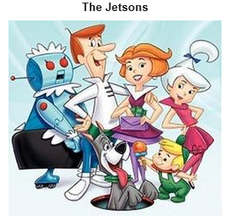

The Jetsons are a middle-class family living in Orbit City. The family consists of:
- George Jetson, the father of the family;
- Jane Jetson, George's wife;
- Judy Jetson, their teenage daughter;
- Elroy Jetson, their young son.
Also part of the family are: Astro, the family's pet dog and Rosey the Robot.
a)Elroy has a sister.
b)George is married to Judy.
c)Rosey is the mother of the family.
d)Jane has two sons.
e)The Jetsons have two dogs.

25. According to the chart, match the columns.
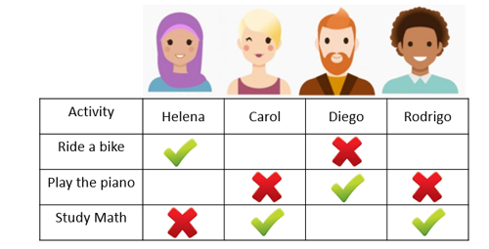
Column 1
1 - Carol and Rodrigo
2 - Helena likes riding a bike
3 - Diego likes
4 - Carol

Column 2
( ) but Diego doesn’t.
( ) playing the piano.
( ) doesn’t like playing the piano.
( ) like studying Math.

