ALUNO (A):

DATA: / / 2019
LISTA DE EXERCÍCIO-INGLÊS

SÉRIE: 6º ANO

1º BIMESTRE

PROFESSOR (A): MARIA GABRIELLA
Nota:

Nº DE QUESTÕES: 25

1. Passe para a forma negativa:
a) Paul is short.
_______________________________________________________

b.Peter is good today.
_______________________________________________________

2. What’s the correct order of the conversation?

( ) What is his name?
( ) His name is Claudio.
( ) Hi Jane. Who is this?
( ) This is my brother.

A) 1,2,3,4
B) 3,4,1,2
C)1,2,4,3
D)4,3,2,1

3. Choose the correct alternative.
WHAT TIME IS IT?

A) IT’S TWELVE O’CLOCK
B) HOW ARE YOU?
C) I AM CATHERINE.
B) IT'S THREE O'CLOCK.

4.What time is it?
5.What time do you go to school? Write in full:

I go to school at: ____________________________________.

6. Marque os adjetivos na forma contraída:
A)You’is
B)You’re
c)You are
D)We is

7. Complete with am, is or are.

a) Franklin ______ my brother.
b) Dylan ______ my father.
c) Bob and Anne ____ my friends.

8. Complete the dialogue.
MOTHER'S NAME SISTER BROTHER FAMILY
This is my ___________. My name is Lisa, and I have a _____________ and a ___________.
My ___________ name is Margie and my father's ___________ is Homer.

9. Complete the dialogue with the words.
AM NICK HELLO

__________! My name is __________.
Hello Nick, I __________ Lucas.

10. Choose the correct alternative.
My name is Carol. I _____________ a ______________.
A) AM; MUSIC B) AM; SINGER

11. Put the dialogue in the correct order.

( ) I'M FINE AND YOU?
( ) HELLO NINA! HOW ARE YOU?
( ) I'M FINE TOO.

12. Complete the dialogue.
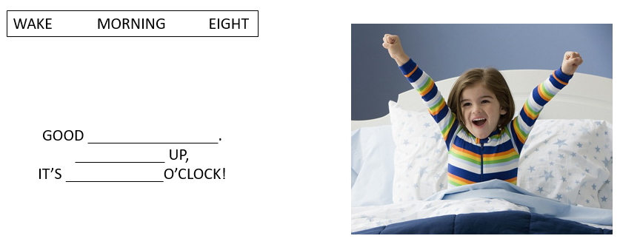
13. Read the dialogue and check the correct question to complete it:

“My name is Hanna. I’m ____________ ITALY and I’m ITALIAN.”

A) FROM
B) TO
C) COUNTRY
D) WHERE

14. Unscrabble the sentences.

a) ? - WHERE – FROM- YOU - ARE
___________________________________________________________

B) FROM - I’M- ARGENTINA
___________________________________________________________

15. Complete the sentences with the words in the box.
THEIR HIS MY OUR

A) ____________ name is Kim.
B) We are friends. ____________ names are John and Finn.
C) This is Felipe. _____________ favorite sport is basketball.
D) They are Tina and Fernanda. _____________ shoes are black.

16. Complete the sentences. With who, what, how:

______________ is your name?
______________ old are you?
______________ is this?

17. Choose the correct option.

__________________ are ________________ from?
A) WHAT; YOU B) WHERE; THEY
________________ are from Italy.
A) HE B) THEY

18. Match the sentences with the time.

A) Nina goes to school in the morning. ( ) Nine thirty a.m.
B) After school she has lunch at home. ( ) Midday
C) In the afternoon Nina plays soccer. ( ) Eight thirty p.m.
D) At night Nina does her homework. ( ) Six p.m.

19. Put the action in the correct order.

( ) I go to school at twelve o'clock.
( ) I wake up at ten past eight.
( ) I play soccer at three p.m.
( ) I have dinner at seven p.m

20. Unscrabble the sentences.
A) ? - IS - WHAT- TIME- IT
____________________________________________________________
B) P.M. – EIGHT - IT’S - THIRTY.
____________________________________________________________

21. Match.
A) Where is she from? ( ) They are from Peru.
B) Where are they from? ( ) She is from the USA.
C) Where is he from? ( ) I am from Brazil.
D) Where are you from? ( ) He is from Colombia.

22. Choose the correct alternative.

What is _____________ name?
A) HIS B) HER
_____________ name is Gabriella.
A) HER B) SHE

23. Choose the correct option to complete the text.
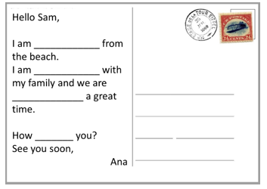
a)writing; traveling; having; are
b)write; traveling; have; are
c)writing; travel; having; is
d)write; travel; having; are

24.Read and answer:

What time is it, please?

Jane: Hey, Carol, what time is it?
Carol: It's eight o'clock.
Jane: Oh, my God!!! I am late. I have to go to Gina's house to study Math.
Carol: Oh, why are going to study Math, Jane?
Jane: Because we have a Math test tomorrow at school.
Carol: I don't like Math because I think it's so difficult to understand.
Jane: Yeah, l think it is difficult, too. But l like it and Gina is good at Math, so she is going to help me.
Carol: Can l go with you, Jane?
Jane: For sure, Carol, but we need to hurry up, because Gina is waiting for me at eight o'clock.
Carol: Ok, let's go!
Glossary
- Help: ajudar
- Late: atrasado
- Tomorrow: amanhã
- Too: também
- Understand: entender
- Why are you going to...: Por que você vai…?
Mark the correct answer according to the text:

a)Carol gosta de Matemática.
b)Gina não gosta de Matemática.
c)Jane acha fácil aprender Matemática.
d)Carol quer ir estudar junto com Jane e Gina.

25. Read the text and fill in the blanks with the possessive adjectives.
Gabriela wakes up everyday at 7 a.m. and has breakfast. She brushes _________ teeth and goes to school. __________ best friend is Teresa. They always do __________ homework together.

a)she; her; our
b)she; her; their
c)her; she; your
d)her; her; their
e)her; she; their

