DATA: / / 2018

PROFESSOR (A): IGOR
LISTA DE EXERCÍCIO DE INGLÊS

SÉRIE: 7º ANO
ALUNO (A): Nº:

NOTA:

2º BIMESTRE

Read the text and answer the questions

SCHOOLS IN AUSTRALIA
School education in Australia includes preschool, preparatory (or kindergarten), primary school, secondary school (or high school) and senior secondary school (or college).
Schooling lasts for 13 years, from preparatory to senior secondary. School is compulsory until at least the age of 16. Types of schools include government schools, non-government schools (including faith-based schools such as Catholic or Islamic schools) and schools based on educational philosophies such as Montessori and Steiner. All schools must be registered with the state or territory education department and are subject to government requirements in terms of infrastructure and teacher registration.
Australian schools do more than just educate students. They prepare them for life − developing communication skills, self-discipline and respect for themselves, their peers and their world. Schools offer a broad curriculum in the key learning areas – English, mathematics, studies of society and the environment, science, arts, Languages Other Than English (LOTE), technology, health and physical education. They also believe strongly in the benefits of a rounded education – including the teamwork, self-expression and personal development that happen outside the classroom.
In Australia, students will enjoy a diverse learning environment that is as personally enriching as it is educational, and develop the skills and qualities needed in a changing world.

1. How long does schooling last in Australia?
a) Schooling lasts for 13 years, from preparatory to Junior secondary
b) Schooling lasts for 13 years, from preparatory to Sophomore secondary
c) Schooling lasts for 13 years, from preparatory to Senior secondary
d) Schooling lasts for 13 years, from preparatory to Elementary secondary

2. Which type of school IS NOT mentioned on the text?
a) Government schools
b) Magnet schools
c) Non-government schools
d) Schools based on educational philosophies such as Montessori and Steiner.
3. What does LOTE stand for?
a) English Language
b) Languages Other Than Spanish
c) No Language At All
d) Languages Other Than English

Look at the map and answer the questions

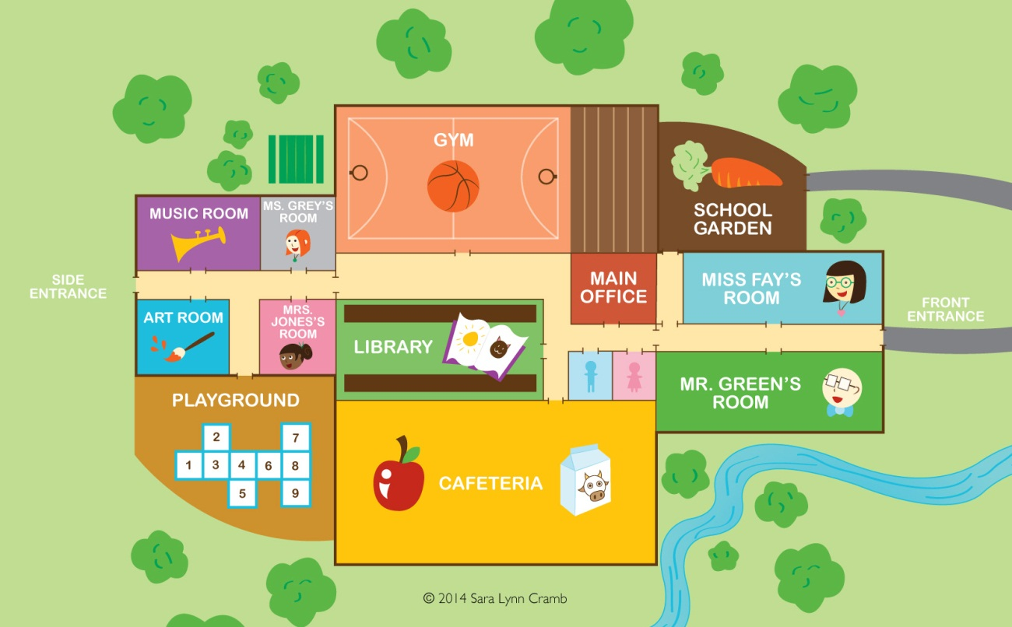

4. Is there a cafeteria on the map?

5. How many restrooms are there on the map?

Look at the clocks and answer the questions.

6. What time is it? ________________________________
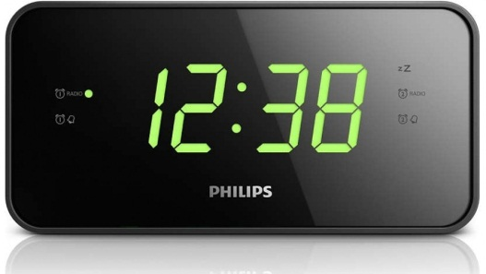 7. What time is it? _________________________

8. Look at the chart and make sentences using CAN or CAN’T.

LUKAS |  | Swim, Dance
 | x | Rollerblade, juggle, paint

JULIA |  | Rollerblade, juggle, paint
 | x | Swim, Dance
a) Lukas / Swim _______________________________________
b) Julia / Dance ________________________________________
c) Lukas / Rollerblade ___________________________________
d) Julia / Juggle ________________________________________

Read the dialogues and answer the questions.

Family World Travel, Because Life is an Adventure
Traveling is our passion and traveling with our children has become our lifestyle. In 2012 we decided to show our kids the world, 4 years of non-stop around the world family travel later, we’re still exploring. Before that there was a whole lifetime of single and couple travel to every corner of the globe. My name is Alyson, I’m a proud mom to our travelling family.

9a How long did they travel around the world?
a) They never traveled around the world
b) They traveled the first time 4 years ago
c) They traveled 4 years non-stop.
d) I don’t know, you should ask them.
e) It is not mentioned.

10a What is the name of the mother in this travelling family?

____________________________________

Now answer the questions according to what you’ve learned in your classes.

11 Look at the clocks and write the correct time.

a) 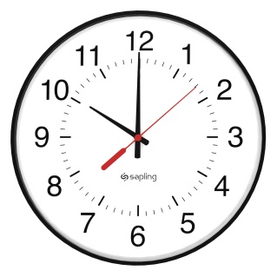 b) 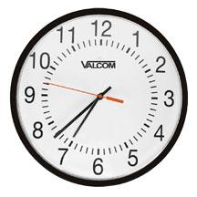 c) 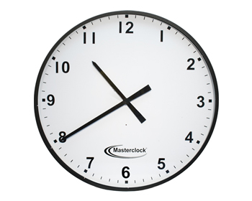

_______________________ ____________________ ____________________

12a Answer the questions with YOUR PERSONAL information.

a) Can you sing well? ____________________________
b) What can you do well? ______________________________
c) What are you doing now? _________________________________

13a Organize and complete the sentences using modal verb CAN.

a) Sing / Julie / Not / Well ________________________
b) Fly / I / Not. _________________________
c) Dance / Lukas. _____________________
d) I / Soccer / Play. ______________________

14a Change into the negative form form.

a) He is riding his bicycle now.
b) I am carrying my backpack.
c) He is listening to music.
d) She is going home.

15a Unscramble the words in the sentences below.

a) going / I / Home / am.
b) is / She / looking at / me;
c) Dad / using / is / computer / his.
d) not / Lucie / is / dancing / now.

16a Write sentences with the verbs about your skills.

a) Swim. ______________________________________________________
b) Dance. ______________________________________________________
c) Play soccer. ______________________________________________________
d) Sing. ______________________________________________________

17ª - Choose the correct alternative that best describe what you are doing now.
a) I am visiting my friends right now.
b) I am studying Portuguese right now.
c) I am taking an English test right now.
d) I am learning Spanish right now.
e) I am not doing anything.

18ª – What time is it now?

06:57 p.m.
a) It’s fifty-seven six.
b) It’s fifty-seven past six.
c) It’s three past six.
d) It’s three to seven.
e) It’s three to six.

The Potter Family
By J.K. Rowling

The Potter family is a very old one, but it was never (until the birth of Harry James Potter) at the very forefront of wizarding history, contenting itself with a solid and comfortable existence in the backwaters.
Potter is a not uncommon Muggle surname, and the family did not make the so-called ‘Sacred Twenty-Eight’ for this reason; the anonymous compiler of that supposedly definitive list of pure-bloods suspected that they had sprung from what he considered to be tainted blood. The wizarding Potter family had illustrious beginnings, however, some of which was hinted at in Deathly Hallows.

19. Write T (true) and F (false).
a) The Potter family isn’t a very old one. ( )
b) Potter is an uncommon Muggle surname. ( )
c) The wizarding Potter family had illustrious beginnings, however, some of which wasn’t hinted at in Deathly Hallows. ( )

20. When did the Potter family got at the forefront of wizarding history?
a) It was always (until the birth of Harry James Potter) at the very forefront of wizarding history.
b) It was (before the birth of Harry James Potter) at the very forefront of wizarding history.
c) It was never (until the birth of Harry James Potter) at the very forefront of wizarding history.
d) It was not mentioned.

21. The Potter family did not make an important list. What is the name of this list?
a) ‘Sacred Twelve-Eight’
b) ‘Sacred Twenty-Eighty’
c) ‘Sacred Twenty-Eight’
d) ‘Secret Twenty-Eight’

22. Choose the best alternative to complete the sentences.
a) She ( like / likes ) rock music.
b) Julio ( not like / doesn’t like ) action movies.
c) He ( watchs / watches ) TV in the morning.

23. Put the adjectives in the correct box.
Good | Bad | Terrible | Gorgeous | Excellent | Fantastic | Horrible | Awful | Cool

POSITIVE CHARACTERISTICS | NEGATIVE CHARACTERISTICS

24. Replace the name for the correct pronoun.
a) I like Bruno Mars. I like _______________
b) I listen to Miley Cyrus. I listen to ________________
c) I don’t like pagode. I don’t like _____________

25. Look at the clocks and write the correct time.
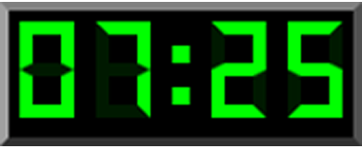

It’s ______________________________

26. Use can or can’t to complete the sentences according to the box.
LUKAS | Activity | MARIANA | Activity
No | Rollerblade | Yes | Dance
Yes | Skateboard | No | Sing

a) Lukas ______________ dance.
b) Mariana ______________ sing.
c) Mariana ______________ rollerblade.
d) Lukas _______________ skateboard.

Choose the best answer to the questions.

27. Do you go to school by bus?
a) Yes, I don’t.
b) No, I do.
c) No, I don’t.
d) None of the above.

28. What time do you go to school?
a) I go to school at 7 p.m.
b) I go to school at midnight.
c) I go to school at 7 a.m.
d) None of the above.

29. Do you take a shower in the morning?
a) Yes, I don’t.
b) No, I do.
c) Yes, I do.
d) None of the above.

30. What time do you take a shower in the morning?
a) I take a shower at 7 p.m.
b) I take a shower at midnight.
c) I don’t take a shower in the morning.
d) None of the above.

