DATA: / / 2018

PROFESSOR (A): IGOR
LISTA DE EXERCÍCIO DE INGLÊS

SÉRIE: 7º ANO
ALUNO (A): Nº:

NOTA:

1º BIMESTRE

Read the dialogues and answer the questions.

Family World Travel, Because Life is an Adventure
Traveling is our passion and traveling with our children has become our lifestyle. In 2012 we decided to show our kids the world, 4 years of non-stop around the world family travel later, we’re still exploring. Before that there was a whole lifetime of single and couple travel to every corner of the globe. My name is Alyson, I’m a proud mom to our travelling family.

1a How long did they travel around the world?
a) They never traveled around the world
b) They traveled the first time 4 years ago
c) They traveled 4 years non-stop.
d) I don’t know, you should ask them.
e) It is not mentioned.

2a What is the name of the mother in this travelling family?

____________________________________

Now answer the questions according to what you’ve learned in your classes.

3a Look at the clocks and write the correct time.

a) b) c)

_______________________ ____________________ ____________________

4a Answer the questions with YOUR PERSONAL information.

a) Can you sing well? ____________________________
b) What can you do well? ______________________________
c) What are you doing now? _________________________________

5a Organize and complete the sentences using modal verb CAN.

a) Sing / Julie / Not / Well ________________________
b) Fly / I / Not. _________________________
c) Dance / Lukas. _____________________
d) I / Soccer / Play. ______________________

6a Change into the negative form form.

a) He is riding his bicycle now.
b) I am carrying my backpack.
c) He is listening to music.
d) She is going home.

7a Unscramble the words in the sentences below.

a) going / I / Home / am.
b) is / She / looking at / me;
c) Dad / using / is / computer / his.
d) not / Lucie / is / dancing / now.

8a Write sentences with the verbs about your skills.

a) Swim. ______________________________________________________
b) Dance. ______________________________________________________
c) Play soccer. ______________________________________________________
d) Sing. ______________________________________________________

9ª - Choose the correct alternative that best describe what you are doing now.
a) I am visiting my friends right now.
b) I am studying Portuguese right now.
c) I am taking an English test right now.
d) I am learning Spanish right now.
e) I am not doing anything.

10ª – What time is it now?

06:57 p.m.

a) It’s fifty-seven six.
b) It’s fifty-seven past six.
c) It’s three past six.
d) It’s three to seven.
e) It’s three to six.

The World's Most Famous Disabled People
Have a disability or medical condition? You are not alone. Many people with disabilities have contributed to society. These include actors, actresses, celebrities, singers, world leaders, and many other famous people.
A disability is often used to refer to individual functioning, including physical impairment, sensory impairment, cognitive impairment, intellectual impairment, mental illness, and various types of chronic diseases.
Of course there are also millions of people worldwide who may not be famous in the sense society deems famous, but still live with, battle, and overcome their disabilities every single day of their lives.
Albert Einstein, Alexander Graham Bell, Cher, Thomas Edison, David Blunkett, George Washington, Francisco de Goya, Hellen Keller, Lord Bron, are some of the most famous challenged people.

11. What is the other term used in the text to refer to "Disabled People"?
a) Blind people
b) Deaf people
c) Challenged people
d) Not mentioned

12. Which ne of these IS NOT a disabilty?
a) Hunger
b) Physical impairment
c) Sensor Impairment
d) Cognitive impairment

13 - Lucy is studying right now. She loves to study. Lucy is an excellent student and she loves English. According to Lucy, she is studying hard because she wants to be a doctor.

What is Lucy doing in order to be a doctor?

A) she is sleeping a lot.
B) she is visiting a lot of doctors.
C) she is doing nothing.
D) she is studying hard.
E) she isn't here.

14 - Choose the best alternative. What time is it?

7:45

A) it's a quarter after seven.
B) it's a quarter to seven.
C) it's a quarter to eight.
D) it's fifteen to seven.
E) it's fifteen after seven.

Read the text and answer the questions

SCHOOLS IN AUSTRALIA

School education in Australia includes preschool, preparatory (or kindergarten), primary school, secondary school (or high school) and senior secondary school (or college).
Schooling lasts for 13 years, from preparatory to senior secondary. School is compulsory until at least the age of 16. Types of schools include government schools, non-government schools (including faith-based schools such as Catholic or Islamic schools) and schools based on educational philosophies such as Montessori and Steiner. All schools must be registered with the state or territory education department and are subject to government requirements in terms of infrastructure and teacher registration.
Australian schools do more than just educate students. They prepare them for life − developing communication skills, self-discipline and respect for themselves, their peers and their world. Schools offer a broad curriculum in the key learning areas – English, mathematics, studies of society and the environment, science, arts, Languages Other Than English (LOTE), technology, health and physical education. They also believe strongly in the benefits of a rounded education – including the teamwork, self-expression and personal development that happen outside the classroom.
In Australia, students will enjoy a diverse learning environment that is as personally enriching as it is educational, and develop the skills and qualities needed in a changing world.

15. How long does schooling last in Australia?
a) Schooling lasts for 13 years, from preparatory to Junior secondary
b) Schooling lasts for 13 years, from preparatory to Sophomore secondary
c) Schooling lasts for 13 years, from preparatory to Senior secondary
d) Schooling lasts for 13 years, from preparatory to Elementary secondary

16. Which type of school IS NOT mentioned on the text?
a) Government schools
b) Magnet schools
c) Non-government schools
d) Schools based on educational philosophies such as Montessori and Steiner.

17. What does LOTE stand for?
a) English Language
b) Languages Other Than Spanish
c) No Language At All
d) Languages Other Than English

Look at the map and answer the questions

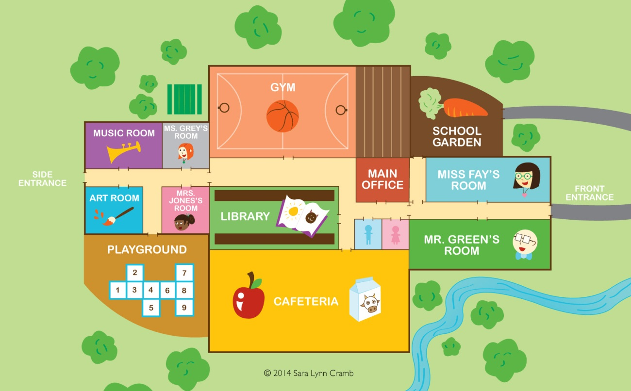

18. Is there a cafeteria on the map?

19. How many restrooms are there on the map?

Look at the clocks and answer the questions.

20. What time is it? _______________________________
21. What time is it? ________________________

22. Look at the chart and make sentences using CAN or CAN’T.

LUKAS |  | Swim, Dance
 | x | Rollerblade, juggle, paint

JULIA |  | Rollerblade, juggle, paint
 | x | Swim, Dance

a) Lukas / Swim ____________________________________________________
b) Julia / Dance ____________________________________________________
c) Lukas / Rollerblade _______________________________________________
d) Julia / Juggle ____________________________________________________

Read the text and answer the questions.

What is Inclusion?
by Shafik Asante

In 1955 the story of a brave and tired woman named Rosa Parks was put in front of this country's awareness. They say this woman had gotten tired, in fact, historically tired of being denied equality. She wanted to be included in society in a full way, something which was denied people labeled as "black" people! So Rosa Parks sat down on a bus in a section reserved for "white" people. When Rosa was told to go to "her place" at the back of the bus, she refused to move, was arrested, and history was challenged and changed. All of this happened because Rosa Parks was tired, historically tired of being excluded. She had sat down and thereby stood up for inclusion! Many people whose abilities are regularly denied or ignored feel that society is not honoring the right to participate in society in a full way. Part of the call is for better accessibility, such as more wheelchair ramps, more signs and materials in braille, community living, etc. Thus, inclusion is giving fair chance for those who were born with difficulties.

23. Why was Rosa put in front of the country’s awareness?
a) She was beautiful.
b) This woman got tired of being denied equality.
c) She got lost.
d) She did nothing.

24. What happened, when Rosa was told to go to "her place" at the back of the bus?
a) She said “no”.
b) She took a train.
c) She refused to move.
d) She did nothing.

