DATA: / / 2018

PROFESSOR (A): IGOR
LISTA DE EXERCÍCIO DE INGLÊS

SÉRIE: 5º ANO
ALUNO (A): Nº:

NOTA:

1º BIMESTRE

Read the dialogues and answer the questions.

Tom: My name is Tom. What’s yours?
Mary: I’m Mary.
Tom: Hi, Mary. What level are you in?
Mary: I’m in Level Three. And you?
Tom: I’m in Level 3, too. So this is the right classroom.

1a What level are they in?
______________________________________________________________

Tom: Do you have any brothers or sisters?
Mary: Yes, I do. I come from a large family.
Tom: Really? How many brothers or sisters do you have?
Mary: I have four brothers and three sisters.
Tom: What country are you from?
Mary: Originally, I’m from Guatemala. But we moved to Mexico three years ago.

2a According to the text, what country is Tom from?
______________________________________________________________

Now answer the questions according to what you’ve learned in your classes.

3a Rewrite the sentences using the correct contractions.

a) You are 11 years old.
b) I am 12 years old.
c) We are Brazilian.
d) They are American.

4a Answer the questions with YOUR PERSONAL information.

a) What is your full name? ____________________________
b) Where are you from? ______________________________
c) How old are you? _________________________________

5a Change the sentences into the negative form.

a) We are Brazilian. ________________________
b) I am American. _________________________
c) We are from Nigeria. _____________________
d) He is from Portugal. ______________________

6a Change into the plural form.

a) This is not my name.
b) That is my backpack.
c) This is my brother, Tony.
d) That is not a good argument.

7a Complete the chart with the correct information.

COUNTRY | NATIONALITY | LANGUAGE
Portugal |  | Portuguese
Brazil
England | English
Spain |  | Spanish
Canada | Canadian

8a Unscramble the words in the sentences below.

a) your / What’s / name / first / ?
b) old / you / are / How / ?
c) What’s / last / your / name / ?
d) nickname / What’s / your / ?

9ª – Fill in the gaps, observing the correct sequence of numbers.

One, Three, Five, Seven ______, Eleven.
Two, Four, Six, _______, Ten.
Three, Six, Nine, ________, Fifteen.
Five, Ten, ________, Twenty.

a) Eight; Twelve; Fifteen; Nine.
b) Nine; Eight; Twelve; Fifteen.
c) Ten; Nine; Fourteen; Nineteen.
d) Eight; Seven; Ten,; Eleven.
e) Ten; Eight; Thirteen; Fifteen.

10ª – Read the text and answer the uestion.

Hi. My name is Erick. I am 12 years old. I am from the United States of America. I am American. My full name is Erick Litt Smith. I live in Oregan with my family. I have two sisters and a brother. Their names are Julie, Lucy and Luke.

According to the text. What is Erick’s nationality?
a) He is United States American
b) He is United States
c) He is America
d) He is American
e) He has no nationality

Portuguese Colonization Of Brazil
Although long inhabited by prehistoric tribes and settlements, Brazil underwent an entirely new kind of habitation during the 16th century. In April 1500, the Portuguese arrived on the Bahian shores of Rio Buranhém, under the direction of Pedro Alvares Cabral. These ones documented seeing indigenous inhabitants upon landing on the beach, who greeted them with peace offerings of headdresses made from parrot feathers.

11. When did the portuguese arrive in Brazil?
a) in April 1500
b) In January 1500
c) In March 1600
d) In April 1600

12. Who was the commander of the Portuguese crew?
a) Cristovam Colombus
b) Pedro Alvares Cabral
c) Brazil was never visited by the Portuguese
d) Not mentioned

13 - Choose the contractions that best complete the text.

- My name's Carlos. I _____ 13 years old. I ______ a student. What ______ your name?

A) 'm; 'm; 's.
B) 's; 'm; 's.
C) 'm; 'm; 'm.
D) 's; 's; 's.
E) 's; 's; 'm.

14. Julie is my best friend. She is nine years old. She is a student. Her full name is Julie Pinkett Smith.

- What is Julie's MIDDLE name? -

A) it's Julie
B) it's Pinkett
C) it's Smith
D) it's Julie Pinkett Smith
E) she doesn't have.

Read the text and answer the questions.

TEXTING SLANG

Only a few short years ago, no one knew what that was. Now, everyone is doing it. Texting involves using a phone, or other device, to send a text message to another mobile device. In other words, it is sort of like instant messaging for your phone. However, because you are using a telephone, you don't usually have a full keyboard at your disposal. Instead, you have to type your message using the numbers on your phone, each of which is associated with a letter. To save time and energy and avoid carpal tunnel of the thumbs, hundreds of different texting slang words and abbreviations have come into play. The problem is, there are too many, if you don't know them all you might think someone is speaking a foreign language! Never fear, though, because here is a list to help you figure out just what on Earth you BFF texted you!

15. What does texting involve?
a) Texting involves using a phone, or other device, to send a text message to another mobile device
b) Texting involves using a book to write messages to other people.
c) Texting involves using a phone, or other device, to send an email to another mobile device
d) Not mentioned.

16. Why have slang words and abbreviations come into play?
a) To play video games.
b) To play with Neymar.
c) To save time and energy.
d) To save ourselves from suffering.

17. According to the text, how many texting slangs are there?
a) There are too many.
b) There are too little.
c) There aren’t any.
d) There are one hundred.

18. Read the numbers and write them down.

a. 12. _________________
b. 13. _________________
c. 17. _________________
d. 19. _________________
e. 20. _________________

19. Read the text and answer the questions below with your own information.

Hi. My name is Leandro Carneiro Silva. I am 12 years old, and I am from Rio de Janeiro. I have two sisters and one brother. My mother’s name is Erika Carneiro.
a) What’s his full name? _______________________
b) What’s his last name? _______________________
c) Where is he from? __________________________

20. Match the pictures to the greetings.

a) Good Evening
b) Good Night
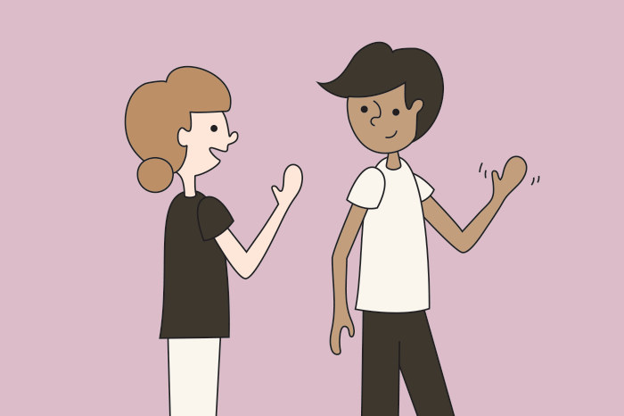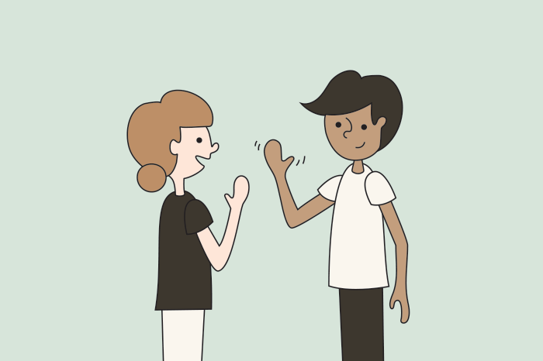

21. Write the correct nationalities.
a) We’re from mexico. ___________________
b) I am from Italy. ____________________
c) She’s from China. _________________________
d) He’s from Spain. __________________________

Read the text and answer the questions.

Before the arrival of the Portuguese in 1500, Brazil was inhabited by nearly five million Amerindians. The Portuguese colonization of Brazil started in the sixteenth century. In the first two centuries of colonization, 100,000 Portuguese arrived in Brazil (around 500 colonists per year). In the eighteenth century, 600,000 Portuguese arrived (6,000 per year). Another race, Blacks, were brought from Africa as slaves, starting around 1550. Many came from Guinea, or from West African countries - by the end of the eighteenth century many had been taken from Congo, Angola and Mozambique (or, in Bahia, from Benin). By the time of the end of the slave trade in 1850, around 3.5 million slaves had been brought to Brazil–37% of all slave traffic between Africa and the Americas.

22. Before 1500, who inhabited Brazil?
a) Portuguese
b) Spanish
c) Amerindians
d) Not Mentioned

23. When were black people brought to Brazil?
a) From 1500
b) In 1520
c) From 1550 on.
d) Not mentioned

