DATA: / / 2018

PROFESSOR (A): IGOR
LISTA DE EXERCÍCIO DE INGLÊS

SÉRIE: 4º ANO
ALUNO (A): Nº:

NOTA:

1º BIMESTRE

1ª – Circle the alternative that best complete the sentences.

a) There ( is / are ) two courts in my school.
b) There ( is / are ) one classroom in my school.
c) There ( is / are ) fifteen classrooms in my school.

2ª – Complete the chart with the information from the text.
Lili and Mary study at different schools. In Mary’s school, there are three teacher’s room, four bathrooms, one art room and two cafeteria. In Lily’s school, there are two teacher’s room, six bathrooms, three art room and one cafeteria.
HOW MANY | LILY’S | MARY’S
TEACHER’S ROOM
ART ROOM
CAFETERIA
BATHROOMS

Look at the map and answer the questions.
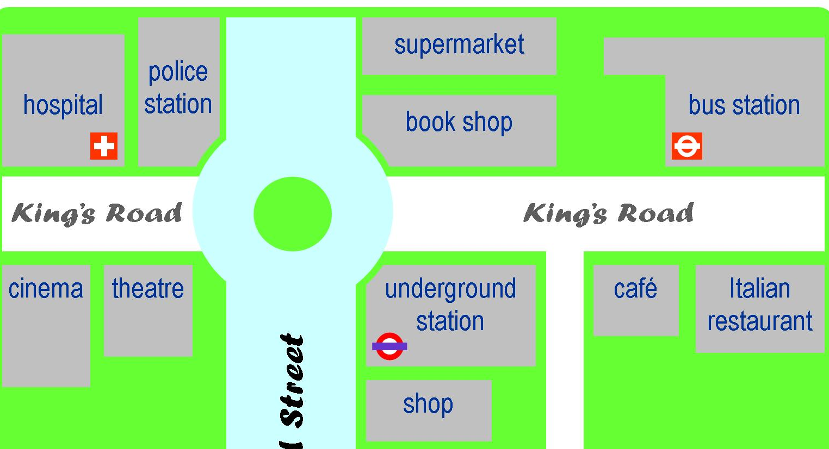
3ª - Where is the Café? It’s _______ the __________, next ________ the __________________________________.

4ª – Where is the Italian Restaurant? ________________________________________.

5ª - Where is the Police Stations? It’s ________ the _________, next ________ the __________________________________.

6ª – Where is the Cinema? ________________________________________________.

7ª – Choose the alternative that contains only places at school.

a) Bedroom; Bathroom; Classroom; Art Room.
b) Bathroom; Kitchen; Bedroom; Art Room.
c) Bathroom; Art Room; Classroom; Teacher’s Room.
d) Bathroom; Art Room; Living Room; Kitchen.
e) Bathroom; Living Room; Garage; Bedroom.

8ª – How many teacher’s room are there in your school (COC-Imperatriz)?

look at the clocks below and answer the questions.
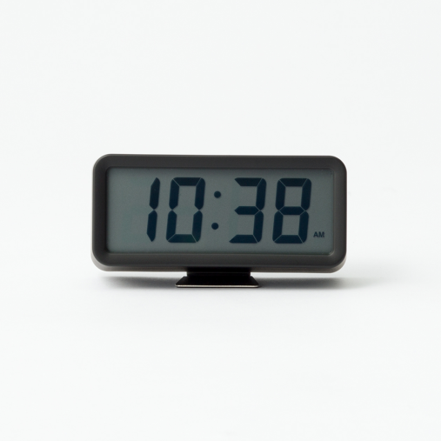

9. What time is it?
a) It's ten twenty eight
b) It's ten thirty eight
c) It's twenty eight past ten
d) It's thirty eight past ten

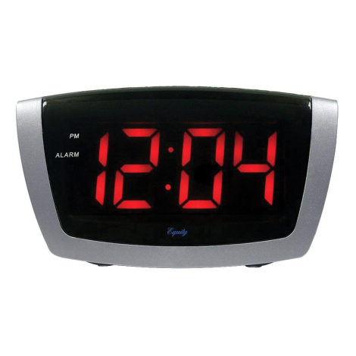
10. What time is it?
a) It's twelve past four
b) It's four past twelve
c) It's four to twelve
d) It's twelve fourteen

11. What time do you start school?
a) School starts at 7:20 in the afternoon.
b) School starts at 7:20 in the evening.
c) School starts at 7:20 in the morning.
d) I don’t go to school.

12. Choose the INCORRECT option.

a) I have lunch at twenty past one.
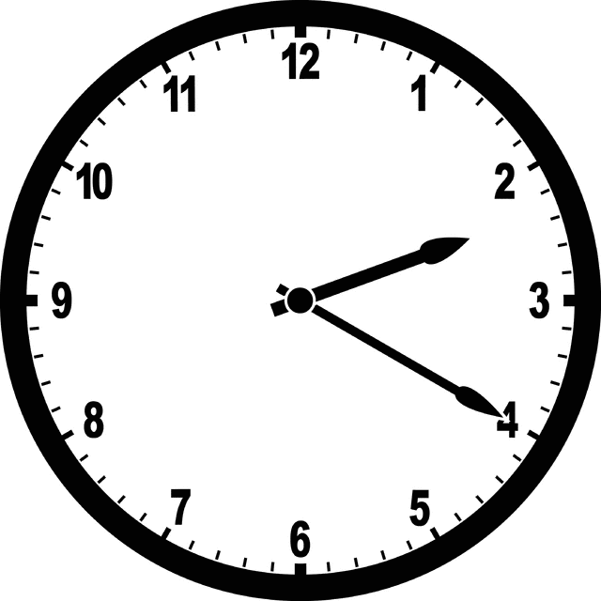
b) I go to school at seven o’clock.
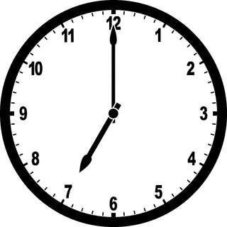

c) I go to bed at half past nine.
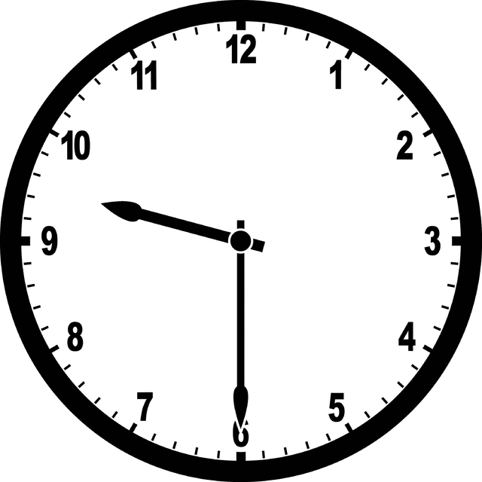
d) I do my homework at three o’clock.
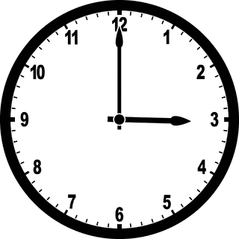

13. What time do you finish school?
a) School finishes at 12:10 in the afternoon.
b) School finishes at 12:10 in the evening.
c) School finishes at 12:10 in the morning.
d) I don’t go to school.

14. Choose the INCORRECT option.

a) I have lunch at twenty past two.
b) I go to school at twelve o’clock.
c) I go to bed at half past nine.
d) I do my homework at three o’clock.

Look at the clocks and choose the option that represent the correct time.

15. What time is it?

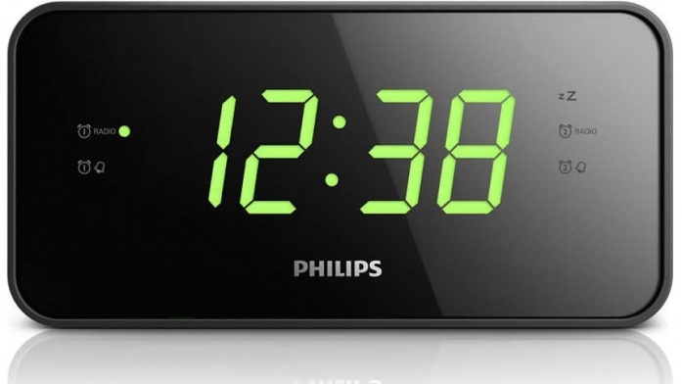
a) It’s twenty thirty
b) It’s twenty thirty eight
c) It’s twelve thirty eight
d) It’s thirty eight twelve

16. What time is it?
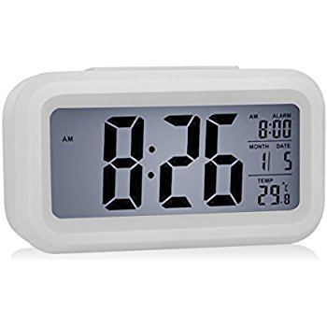
a) It’s twenty eight past eight
b) It’s twelve eight past eight
c) It’s eight twenty
d) It’s thirty two to nine

READ THE TEXT AND ANSWER QUESTIONS 1, 2 AND 3 BELOW.
Julia and Andrea study at COC-Imperatriz, a big school in this city. There are so many rooms in their school, they sometimes get lost. There are three big teacher’s rooms there. There are also one big lab, and six bathrooms. There aren’t art rooms, but there are sixteen classrooms.

17. How many art rooms are there in their school?

____________________________________________

18. How many bathrooms are there in their school?

____________________________________________
19. How many rooms are there in their school?

____________________________________________

20. Read the text below and complete with is or are.

In my school, there ______ one teacher’s room. There _______ five bathrooms. There ______ big court. There _______ sixteen classrooms.

21. OMG! I can’t believe I forgot Julie’s party this weekend. I have to go. She never missed any of my parties. Here is the map to her house, do you think I’ll find it easily?

a) Where is my house?
It’s on the ________________________ next to _____________________________.

