DATA DA PROVA: / / 2017

PROFESSOR (A): CARLOS
ATIVIDADE DE RECUPERAÇÃO - INGLÊS

SÉRIE: 5º ANO
ALUNO (A): Nº:

TURMA:
NOTA:

3º BIMESTRE

- Preencha o cabeçalho de forma legível e completa.
- A interpretação das questões faz parte da avaliação.
- Certifique-se de que, em cada questão, todo o desenvolvimento e as operações estejam explícitos, o não cumprimento do item anulará a questão.
- Utilize somente caneta de tinta azul ou preta. Prova feita a lápis não será corrigida e não terá direito à revisão.
- Serão anuladas as avaliações em que forem constatados: termos pejorativos ou desenhos inadequados.
- Procure cuidar da boa apresentação de sua prova (organização, clareza, letra legível).
- As respostas com rasuras e/ou líquido corretor não serão revisadas e nem aceitas.
- Não é permitido ter celulares e/ou objetos eletrônicos junto ao corpo, sobre a carteira ou com fácil acesso ao aluno durante a realização da avaliação, sob pena de sua anulação.
- Em caso de “cola” a prova será anulada e zerada imediatamente pelo professor ou fiscal de sala.
INSTRUÇÕES

- Find five music genres. (Encontre cinco gêneros musicais.)
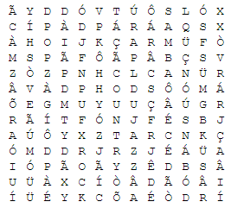

Texto:

Hi. My name is Josh and I love celebrations. My favorite celebration is Easter. On easter we get chocolate as presents. I love chocolate. I like Christmas too because I eat a lot of good food and I get many presents. I don’t like The New Year celebration because it’s loud and noisy and I don’t like fireworks. I like Carnaval because of the music. I like samba and Pop music. They are the best!
Questões:

- What is Josh’s favorite celebration? (Qual é a celebração favorite de Josh?)

- Why does he like Easter? (Por que ele gosta da Páscoa?)

- What other celebrations does he like? (Quais outras celebrações ele gosta?)

- Why doesn’t Josh like The New Year party? (Por que ele não gosta da festa de ano novo?)

- What music kinds does he like to listen to? (Quais tipos de música ele gosta de ouvir?)

- Escreva em inglês qual festa você menos gosta e justifique.

- Escreva em inglês qual festa você mais gosta e justifique.

Leia o texto e responda as perguntas
The United States is a large country. It is the third largest in the whole world! It is located in a continent called North America. Parts of the United States touch three different oceans. The United States has tall mountains, prairies, deserts, hills, rivers, lakes, volcanoes, and even rain forests! People from all over the world have come to live in the United States.

There are 50 states in the United States. The newest states, Alaska and Hawaii, are not connected to the other states. Alaska is the largest state, and Hawaii is a chain of islands in the Pacific Ocean.

- De acordo com o texto, em qual continente está localizado os Estados Unidos?

- Os Estados Unidos são banhados por quantos oceanos diferentes?

- Quais tipos de relevo e vegetação podemos encontrar nos EUA?

- Quais os dois estados dos Estados Unidos são citados no texto?

- Find at least three monuments in the wordsearch below. (Encontre pelo menos três monumentos no palavra-cruzada abaixo.
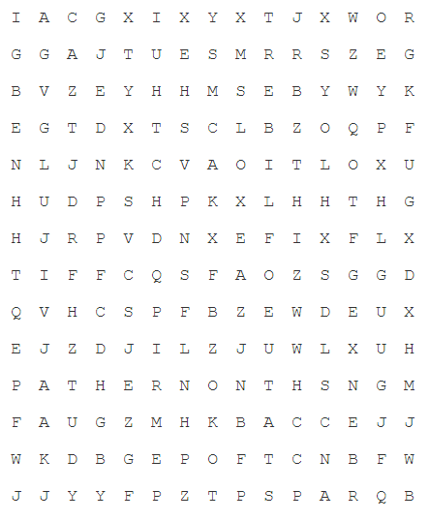

Read the text and answer the questions

The Eiffel Tower is a very famous tower in Paris, France. It was named after the engineer who designed and built it, Alexandre Eiffel. The tower was built in 1889.
The Eiffel Tower is sometimes considered one of the seven wonders of the modern world. It is 300 meters high and people can take an elevator all the way to the top. From the tower, they can get a marvellous view of the city and the River Seine which runs through it. Besides the elevator, there are steps which lead all the way up the tower. For those who are energetic, they can use these to climb up. It is very windy at the top of the tower and can be very cold at times because it is only built by iron beams. There are no walls to keep the wind out.

- What is the text about? (Sobre o que se trata o texto?)

- How did the Eiffel tower get its name? (Como a torre Eiffel conseguiu esse nome?)

- How is the weather at the top of the tower? (Como é o tempo no topo da torre?)

Leia o diálogo da página 41 e 42 do livro de inglês e responda às questões abaixo
- Sobre o que eles estão conversando?

- De acordo com a amiga de Daniel, qual tipo de lugar ela acha mais bonito?

- Que lugares Daniel e sua amiga gostariam de visitar?

- Faça uma pesquisa e cite pelo menos um local de cada tipo de ambiente da natureza contido na página 42.

- Traduza o texto contido no balão de fala da página 42.

Responda em inglês:
- What natural places do you think are the most beautiful?

- Describe some places you visited.

