

## DATA DA ATIVIDADE: / / 2017

## PROFESSOR (A): LYVIA

**ATIVIDADE DE RECUPERAÇÃO -INGLÊS**

# SÉRIE: 6º ANO

**ALUNO (A): Nº:**

### TURMA:

**NOTA:**

**1.*Found the words: (Encontre as palavras)***

|  |  |  |  |  |  |  |  |  |  |  |  |  |  |  |  |  |  |  |  |  |  |  |  |  |  |  |  |  |  |  |  |  |  |  |  |  |  |  |  |  |  |  |  |  |  |  |  |  |  |  |  |  |  |  |  |  |  |  |  |  |  |  |  |  |  |  |  |  |  |  |  |  |  |  |  |  |  |  |  |  |  |  |  |  |  |  |  |  |  |  |  |  |  |  |  |  |  |  |  |  |  |  |  |  |  |  |  |  |  |  |  |  |  |  |  |  |  |  |  |  |  |  |  |  |  |  |  |  |  |  |  |  |  |  |  |  |  |  |  |  |  |  |  |  |  |  |  |  |  |  |  |  |  |  |  |  |  |  |  |  |  |  |  |  |  |  |  |  |  |  |  |  |  |  |  |  |  |  |  |  |  |  |  |  |  |  |  |  |  |  |  |  |  |  |  |  |  |  |  |  |  |  |  |  |  |  |  |  |  |  |  |  |  |  |  |  |  |  |  |  |  |  |  |  |  |  |
| --- | --- | --- | --- | --- | --- | --- | --- | --- | --- | --- | --- | --- | --- | --- | --- | --- | --- | --- | --- | --- | --- | --- | --- | --- | --- | --- | --- | --- | --- | --- | --- | --- | --- | --- | --- | --- | --- | --- | --- | --- | --- | --- | --- | --- | --- | --- | --- | --- | --- | --- | --- | --- | --- | --- | --- | --- | --- | --- | --- | --- | --- | --- | --- | --- | --- | --- | --- | --- | --- | --- | --- | --- | --- | --- | --- | --- | --- | --- | --- | --- | --- | --- | --- | --- | --- | --- | --- | --- | --- | --- | --- | --- | --- | --- | --- | --- | --- | --- | --- | --- | --- | --- | --- | --- | --- | --- | --- | --- | --- | --- | --- | --- | --- | --- | --- | --- | --- | --- | --- | --- | --- | --- | --- | --- | --- | --- | --- | --- | --- | --- | --- | --- | --- | --- | --- | --- | --- | --- | --- | --- | --- | --- | --- | --- | --- | --- | --- | --- | --- | --- | --- | --- | --- | --- | --- | --- | --- | --- | --- | --- | --- | --- | --- | --- | --- | --- | --- | --- | --- | --- | --- | --- | --- | --- | --- | --- | --- | --- | --- | --- | --- | --- | --- | --- | --- | --- | --- | --- | --- | --- | --- | --- | --- | --- | --- | --- | --- | --- | --- | --- | --- | --- | --- | --- | --- | --- | --- | --- | --- | --- | --- | --- | --- | --- | --- | --- | --- | --- | --- | --- | --- | --- | --- | --- | --- | --- |
| |  |  |  |  |  |  |  |  |  |  |  |  |  |  |  | | --- | --- | --- | --- | --- | --- | --- | --- | --- | --- | --- | --- | --- | --- | --- | | http://englishexercises.org/images/word_search/G.jpg | http://englishexercises.org/images/word_search/O.jpg | http://englishexercises.org/images/word_search/O.jpg | http://englishexercises.org/images/word_search/D.jpg | http://englishexercises.org/images/word_search/M.jpg | http://englishexercises.org/images/word_search/O.jpg | http://englishexercises.org/images/word_search/R.jpg | http://englishexercises.org/images/word_search/N.jpg | http://englishexercises.org/images/word_search/I.jpg | http://englishexercises.org/images/word_search/N.jpg | http://englishexercises.org/images/word_search/G.jpg | http://englishexercises.org/images/word_search/s.jpg | http://englishexercises.org/images/word_search/d.jpg | http://englishexercises.org/images/word_search/f.jpg | http://englishexercises.org/images/word_search/g.jpg | | http://englishexercises.org/images/word_search/h.jpg | http://englishexercises.org/images/word_search/j.jpg | http://englishexercises.org/images/word_search/k.jpg | http://englishexercises.org/images/word_search/l.jpg | http://englishexercises.org/images/word_search/z.jpg | http://englishexercises.org/images/word_search/x.jpg | http://englishexercises.org/images/word_search/c.jpg | http://englishexercises.org/images/word_search/v.jpg | http://englishexercises.org/images/word_search/b.jpg | http://englishexercises.org/images/word_search/n.jpg | http://englishexercises.org/images/word_search/m.jpg | http://englishexercises.org/images/word_search/z.jpg | http://englishexercises.org/images/word_search/a.jpg | http://englishexercises.org/images/word_search/q.jpg | http://englishexercises.org/images/word_search/x.jpg | | http://englishexercises.org/images/word_search/s.jpg | http://englishexercises.org/images/word_search/w.jpg | http://englishexercises.org/images/word_search/c.jpg | http://englishexercises.org/images/word_search/d.jpg | http://englishexercises.org/images/word_search/e.jpg | http://englishexercises.org/images/word_search/v.jpg | http://englishexercises.org/images/word_search/f.jpg | http://englishexercises.org/images/word_search/r.jpg | http://englishexercises.org/images/word_search/b.jpg | http://englishexercises.org/images/word_search/g.jpg | http://englishexercises.org/images/word_search/t.jpg | http://englishexercises.org/images/word_search/n.jpg | http://englishexercises.org/images/word_search/h.jpg | http://englishexercises.org/images/word_search/y.jpg | http://englishexercises.org/images/word_search/m.jpg | | http://englishexercises.org/images/word_search/j.jpg | http://englishexercises.org/images/word_search/u.jpg | http://englishexercises.org/images/word_search/k.jpg | http://englishexercises.org/images/word_search/i.jpg | http://englishexercises.org/images/word_search/H.jpg | http://englishexercises.org/images/word_search/o.jpg | http://englishexercises.org/images/word_search/p.jpg | http://englishexercises.org/images/word_search/o.jpg | http://englishexercises.org/images/word_search/l.jpg | http://englishexercises.org/images/word_search/g.jpg | http://englishexercises.org/images/word_search/j.jpg | http://englishexercises.org/images/word_search/t.jpg | http://englishexercises.org/images/word_search/G.jpg | http://englishexercises.org/images/word_search/d.jpg | http://englishexercises.org/images/word_search/s.jpg | | http://englishexercises.org/images/word_search/i.jpg | http://englishexercises.org/images/word_search/e.jpg | http://englishexercises.org/images/word_search/g.jpg | http://englishexercises.org/images/word_search/a.jpg | http://englishexercises.org/images/word_search/b.jpg | http://englishexercises.org/images/word_search/E.jpg | http://englishexercises.org/images/word_search/s.jpg | http://englishexercises.org/images/word_search/k.jpg | http://englishexercises.org/images/word_search/x.jpg | http://englishexercises.org/images/word_search/k.jpg | http://englishexercises.org/images/word_search/f.jpg | http://englishexercises.org/images/word_search/r.jpg | http://englishexercises.org/images/word_search/O.jpg | http://englishexercises.org/images/word_search/l.jpg | http://englishexercises.org/images/word_search/f.jpg | | http://englishexercises.org/images/word_search/l.jpg | http://englishexercises.org/images/word_search/c.jpg | http://englishexercises.org/images/word_search/f.jpg | http://englishexercises.org/images/word_search/d.jpg | http://englishexercises.org/images/word_search/k.jpg | http://englishexercises.org/images/word_search/j.jpg | http://englishexercises.org/images/word_search/L.jpg | http://englishexercises.org/images/word_search/p.jpg | http://englishexercises.org/images/word_search/o.jpg | http://englishexercises.org/images/word_search/i.jpg | http://englishexercises.org/images/word_search/r.jpg | http://englishexercises.org/images/word_search/t.jpg | http://englishexercises.org/images/word_search/O.jpg | http://englishexercises.org/images/word_search/o.jpg | http://englishexercises.org/images/word_search/q.jpg | | http://englishexercises.org/images/word_search/G.jpg | http://englishexercises.org/images/word_search/O.jpg | http://englishexercises.org/images/word_search/O.jpg | http://englishexercises.org/images/word_search/D.jpg | http://englishexercises.org/images/word_search/A.jpg | http://englishexercises.org/images/word_search/l.jpg | http://englishexercises.org/images/word_search/g.jpg | http://englishexercises.org/images/word_search/L.jpg | http://englishexercises.org/images/word_search/k.jpg | http://englishexercises.org/images/word_search/a.jpg | http://englishexercises.org/images/word_search/s.jpg | http://englishexercises.org/images/word_search/n.jpg | http://englishexercises.org/images/word_search/D.jpg | http://englishexercises.org/images/word_search/s.jpg | http://englishexercises.org/images/word_search/k.jpg | | http://englishexercises.org/images/word_search/j.jpg | http://englishexercises.org/images/word_search/f.jpg | http://englishexercises.org/images/word_search/p.jpg | http://englishexercises.org/images/word_search/i.jpg | http://englishexercises.org/images/word_search/F.jpg | http://englishexercises.org/images/word_search/e.jpg | http://englishexercises.org/images/word_search/G.jpg | http://englishexercises.org/images/word_search/O.jpg | http://englishexercises.org/images/word_search/O.jpg | http://englishexercises.org/images/word_search/D.jpg | http://englishexercises.org/images/word_search/B.jpg | http://englishexercises.org/images/word_search/Y.jpg | http://englishexercises.org/images/word_search/E.jpg | http://englishexercises.org/images/word_search/l.jpg | http://englishexercises.org/images/word_search/k.jpg | | http://englishexercises.org/images/word_search/j.jpg | http://englishexercises.org/images/word_search/s.jpg | http://englishexercises.org/images/word_search/d.jpg | http://englishexercises.org/images/word_search/h.jpg | http://englishexercises.org/images/word_search/T.jpg | http://englishexercises.org/images/word_search/r.jpg | http://englishexercises.org/images/word_search/u.jpg | http://englishexercises.org/images/word_search/i.jpg | http://englishexercises.org/images/word_search/t.jpg | http://englishexercises.org/images/word_search/r.jpg | http://englishexercises.org/images/word_search/o.jpg | http://englishexercises.org/images/word_search/q.jpg | http://englishexercises.org/images/word_search/V.jpg | http://englishexercises.org/images/word_search/w.jpg | http://englishexercises.org/images/word_search/y.jpg | | http://englishexercises.org/images/word_search/e.jpg | http://englishexercises.org/images/word_search/r.jpg | http://englishexercises.org/images/word_search/u.jpg | http://englishexercises.org/images/word_search/b.jpg | http://englishexercises.org/images/word_search/E.jpg | http://englishexercises.org/images/word_search/d.jpg | http://englishexercises.org/images/word_search/s.jpg | http://englishexercises.org/images/word_search/a.jpg | http://englishexercises.org/images/word_search/i.jpg | http://englishexercises.org/images/word_search/o.jpg | http://englishexercises.org/images/word_search/d.jpg | http://englishexercises.org/images/word_search/m.jpg | http://englishexercises.org/images/word_search/E.jpg | http://englishexercises.org/images/word_search/b.jpg | http://englishexercises.org/images/word_search/x.jpg | | http://englishexercises.org/images/word_search/z.jpg | http://englishexercises.org/images/word_search/v.jpg | http://englishexercises.org/images/word_search/c.jpg | http://englishexercises.org/images/word_search/v.jpg | http://englishexercises.org/images/word_search/R.jpg | http://englishexercises.org/images/word_search/a.jpg | http://englishexercises.org/images/word_search/z.jpg | http://englishexercises.org/images/word_search/x.jpg | http://englishexercises.org/images/word_search/s.jpg | http://englishexercises.org/images/word_search/w.jpg | http://englishexercises.org/images/word_search/e.jpg | http://englishexercises.org/images/word_search/d.jpg | http://englishexercises.org/images/word_search/N.jpg | http://englishexercises.org/images/word_search/e.jpg | http://englishexercises.org/images/word_search/f.jpg | | http://englishexercises.org/images/word_search/G.jpg | http://englishexercises.org/images/word_search/O.jpg | http://englishexercises.org/images/word_search/O.jpg | http://englishexercises.org/images/word_search/D.jpg | http://englishexercises.org/images/word_search/N.jpg | http://englishexercises.org/images/word_search/I.jpg | http://englishexercises.org/images/word_search/G.jpg | http://englishexercises.org/images/word_search/H.jpg | http://englishexercises.org/images/word_search/T.jpg | http://englishexercises.org/images/word_search/b.jpg | http://englishexercises.org/images/word_search/t.jpg | http://englishexercises.org/images/word_search/n.jpg | http://englishexercises.org/images/word_search/I.jpg | http://englishexercises.org/images/word_search/t.jpg | http://englishexercises.org/images/word_search/m.jpg | | http://englishexercises.org/images/word_search/y.jpg | http://englishexercises.org/images/word_search/j.jpg | http://englishexercises.org/images/word_search/s.jpg | http://englishexercises.org/images/word_search/k.jpg | http://englishexercises.org/images/word_search/O.jpg | http://englishexercises.org/images/word_search/o.jpg | http://englishexercises.org/images/word_search/l.jpg | http://englishexercises.org/images/word_search/o.jpg | http://englishexercises.org/images/word_search/p.jpg | http://englishexercises.org/images/word_search/m.jpg | http://englishexercises.org/images/word_search/n.jpg | http://englishexercises.org/images/word_search/b.jpg | http://englishexercises.org/images/word_search/N.jpg | http://englishexercises.org/images/word_search/c.jpg | http://englishexercises.org/images/word_search/x.jpg | | http://englishexercises.org/images/word_search/z.jpg | http://englishexercises.org/images/word_search/a.jpg | http://englishexercises.org/images/word_search/w.jpg | http://englishexercises.org/images/word_search/e.jpg | http://englishexercises.org/images/word_search/O.jpg | http://englishexercises.org/images/word_search/t.jpg | http://englishexercises.org/images/word_search/y.jpg | http://englishexercises.org/images/word_search/p.jpg | http://englishexercises.org/images/word_search/o.jpg | http://englishexercises.org/images/word_search/i.jpg | http://englishexercises.org/images/word_search/l.jpg | http://englishexercises.org/images/word_search/f.jpg | http://englishexercises.org/images/word_search/G.jpg | http://englishexercises.org/images/word_search/j.jpg | http://englishexercises.org/images/word_search/a.jpg | | http://englishexercises.org/images/word_search/s.jpg | http://englishexercises.org/images/word_search/q.jpg | http://englishexercises.org/images/word_search/w.jpg | http://englishexercises.org/images/word_search/e.jpg | http://englishexercises.org/images/word_search/N.jpg | http://englishexercises.org/images/word_search/w.jpg | http://englishexercises.org/images/word_search/e.jpg | http://englishexercises.org/images/word_search/s.jpg | http://englishexercises.org/images/word_search/k.jpg | http://englishexercises.org/images/word_search/d.jpg | http://englishexercises.org/images/word_search/f.jpg | http://englishexercises.org/images/word_search/j.jpg | http://englishexercises.org/images/word_search/h.jpg | http://englishexercises.org/images/word_search/g.jpg | http://englishexercises.org/images/word_search/u.jpg | | GOOD MORNING  HELLO  GOOD EVENING    GOOD BYE    GOOD AFTERNOON    GOOD NIGHT |

1. ***Write the correct greeting under each picture. (Escreva o greeting correto abaixo de cada imagem.)***

a)    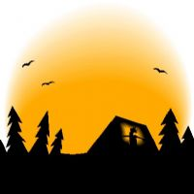     b)      c)   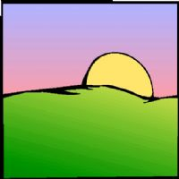     d)   

a)________________________________________________

b)________________________________________________

c)________________________________________________

d)________________________________________________

***3.Unscramble the following words: (Desembaralhe as seguintes palavras:)***

a) odoG ronMing ______________________________________________

b) eloHl _______________________________________________________

c) Godo envEnig_________________________________________________

d) dogo yeB____________________________________________________

e) dooG Atrenofon________________________________________________

f) ghtni doog_____________________________________________________

g) ih____________________________________

***4)Match. (Ligue.)***

a - What's your name?       Bye.

b - Hi!                                 Fine.

c - How are you?                 Hello!

d - Goodbye.                        My name is Sandy.

***5) Complete the conversation: (Complete a conversação:)***

a) ***Paulo:*** ___________ , Angela!

***Angela***: ____________, Paulo ! How are you?

***Paulo:*** I’m great, thanks.

b)***Bia:*** Hello, Tamires ! How _________you?

***Tamires:***___________ , I’m not bad.

c) ***Cris:*** See you tomorrow, Bobby!

***Bobby***:_______________See you.

d) ***Paola:*** Bye , Cintia !

***Cintia***:_________________Paola!

e) ***Joe:*** Good Morning Pedro!

***Pedro:*** ________________,Joe.

6) ***Found the numbers in english:***.(Encontre os números em inglês:)

Numbers:

a) Quarenta e quatro

b) Décimo terceiro

c) Setenta e um

d) Décimo nono

e) Nono

|  |  |  |  |  |  |  |  |  |  |  |  |  |  |
| --- | --- | --- | --- | --- | --- | --- | --- | --- | --- | --- | --- | --- | --- |
| U | Q | T | L | Z | N | V | A | U | O | X | M | W | Q |
| S | X | R | V | Q | H | E | R | R | Z | J | B | V | I |
| M | A | E | D | D | Y | X | B | J | S | B | B | T | I |
| X | H | N | T | Y | B | F | P | E | N | T | U | G | S |
| Y | H | O | C | W | X | O | U | Z | B | B | H | D | E |
| N | T | Y | D | M | Z | R | A | T | M | I | T | M | J |
| O | N | T | H | B | M | T | W | M | J | M | N | G | S |
| F | E | N | U | J | A | Y | X | Z | B | D | E | Z | E |
| F | E | E | A | C | B | F | I | M | V | U | E | U | X |
| I | T | V | Z | Q | M | O | V | V | T | D | T | G | R |
| D | E | E | P | C | X | U | W | N | E | X | R | Z | P |
| N | N | S | B | X | Z | R | O | G | E | O | I | J | X |
| D | I | Y | V | X | V | X | O | G | R | G | H | J | H |
| P | N | I | N | T | H | H | H | H | G | I | T | Y | F |

7) Identify the numbers in the second column acording to the first:(Identifique os números na segunda coluna de acordo com a primeira:).

|  |  |
| --- | --- |
| (A) trinta e dois  (B) dois milhões  (C) centésimo  (D) quarenta e três  (E) vinte e sete | ( ) one hundredth  ( ) two million  ( ) twenty-seven  ( ) thirty-two  ( ) forty-three |

8) Write the numbers in english:(Escreva os números em inglês:)

a) Vinte -

b) Duzentos e vinte cinco -

c) Dezesseis -

d) Setenta e dois -

e) Onze -

9) Organize the letters and found what are the numbers and write its meaning in portuguese: (Organize as letras e encontre os números e escreva o significado em inglês:)

For exemple:

Oen drehund - One hundred Significado: Cem

a) Forsy-tix -_______________________________________________________________

b) Feftienth - ______________________________________________________________

c) Fihtf - __________________________________________________________________

d) Teenty-ninw - ___________________________________________________________

e) One mililonth -___________________________________________________________

10) Identify what this words are ordinal numbers and underline: (Identifique quais dessas palavras são números ordinais e sublinhe-as: )

SIX HUNDRED, NINETY-SIX, SIXTY-SEVEN, SEVENTY, TWO HUNDRED, ONE HUNDRED AND TEN, TWENTY-TWO, TWO HUNDRED AND SIXTY-EIGHT, FIFTIETH, SIXTY, FOURTEENTH, FIFTY-FIVE, SIXTY-ONE, FORTIETH, SIXTY-THREE, TWENTY-FIRST, EIGHTY-SIX, SEVENTY-EIGHT, SEVENTY THREE, ONE MILLION

11) Identify the numbers in the second column acording to the first: (Identifique os números na segunda coluna de acordo com a primeira :)

|  |  |
| --- | --- |
| (A) setenta e sete  (B) mil  (C) dezoito  (D) décimo oitavo  (E) cinco milhões | ( ) one thousand  ( ) eighteen  ( ) seventy-seven  ( ) five million  ( ) eighteenth |

12) Identify what words are cardinal numbers. (Identifique quais das palavras são números cardinais:)

THIRTY-SEVEN, FORTY-SEVEN, THIRTY-FIVE, TWENTY-FIVE, ONE HUNDRED AND FOUR, TWO THOUSAND AND TWENTY, FORTY-THIRD, THREE HUNDRED, ONE HUNDRED AND SEVENTY, NINETY-FIVE, THIRTY-FOUR, EIGHTY-EIGHT, EIGHTY-TWO, TWELVE, NINETIETH, THIRTY-EIGHT, TWO THOUSAND, FIVE THOUSAND AND EIGHT HUNDRED, SIX THOUSAND, NINETY-FOUR

13) Found in the word-search the given words in english:(Encontre no caça-palavras as palavras dadas em inglês:)

Numbers:

a) Dez

b) Quarenta e dois

c) Sexagésimo

d) Quarenta

e) Dezenove

|  |  |  |  |  |  |  |  |  |  |  |  |
| --- | --- | --- | --- | --- | --- | --- | --- | --- | --- | --- | --- |
| F | O | R | T | Y | T | W | O | Y | I | L | M |
| N | E | E | T | E | N | I | N | U | B | J | X |
| C | F | I | R | J | F | H | T | X | T | A | K |
| G | O | N | P | Q | Y | J | W | M | E | W | E |
| O | R | A | N | X | D | S | A | L | N | H | P |
| N | T | S | M | S | L | R | I | C | Q | O | E |
| J | Y | U | D | W | Q | B | X | I | W | M | D |
| T | S | S | I | X | T | I | E | T | H | U | T |
| U | F | B | X | T | B | X | Z | Q | G | T | A |
| V | C | Q | M | H | M | L | M | D | M | Q | L |
| A | P | V | R | N | E | D | C | D | R | F | K |
| J | M | Z | M | B | T | H | E | W | P | G | H |

***Read the text and answer the questions: (Leia o texto e responda as questões:)***

**CHINATOWN**

When the Chinese immigrate to diferente countries, they sometimes create a small town inside the new city - a Chinatown.

There are many Chinatowns around the worlld, like in London, England, in Sydiney, Australia and in Vancouver, Canada. In the USA there are Chinatowns in New York, Chicago, Boston, and many others cities. The biggest Chinatown in the USA and in the world is in San Francisco.

There are many store and restaurants in Chinatown. There are Chinese banks and Chinese monuments. People speak Chinese on the street. They celebrate Chinese New Year. It´s a Chinese home in a foreign land.

14- Are there many Chinatowns around the world? (Existem muitos Chinatowns pelo mundo?)

________________________________________________________________________

15- Whre are these cities? Complete the answers: (Onde estão essas cidades? Complete e responda:)

a) Vancouver is in _________________________________________________________

b) Sydney is in ____________________________________________________________

c) London is in ____________________________________________________________

d) San Francisco is in_______________________________________________________

16- Where is the biggest Chinatown in the world? (Onde está a maior Chinatown no mundo?)

________________________________________________________________________

Look at this Picture and the prices:

Hamburger...................................................$ 2.50

Salad..........................................................$ 1.45

Soup..........................................................$ 1.18

Pizza (slice)..................................................$ 1.30

Ham sandwich...............................................$ 1.65

Cheese sandwich........................................$ 1.70

Ham and Cheese sandwich..........................$ 1.95

Hot dog......................................................$ 1.50

Banana.......................................................$ 60 ₵

Apple.........................................................$ 38 ₵

Pear...........................................................$ 62 ₵

Yogurt........................................................$ 90 ₵

Orange juice...............................................$ 1.00

Milk............................................................$ 80 ₵

HELP BOX

$ = dollar

$ 2.00 = two dollars

$ 2.20 = two dollars and twenty cents

17- How much are the slices of pizzas? (Quanto custam as fatias de pizza?)

________________________________________________________________________________________________________________________________________________

18- How much is the milk? (Quanto custa o leite?)

________________________________________________________________________________________________________________________________________________

19- How much are the ham sandwich? (Quanto custa o sanduiche?)

________________________________________________________________________________________________________________________________________________

**Now you write the question: (Agora escreva as questões:)**

20- _____________________________________________________________________

They´re one dollar and fifty cents each.

21- _____________________________________________________________________

It´s one dollar.

22- _____________________________________________________________________

They´re one dollar and seventy cents each.

23- _____________________________________________________________________

They´re sixty-two cents each.

24- _____________________________________________________________________

They´re sixty cents each.

25- Complete the sentences with the to be form and with the subject indicated in its negative and interrogative form:   
(Complete as frases com a forma a ser e com o sujeito indicado em sua forma negativa e interrogativa:)

1. ______________ going to the game tonight?

(They) 2. The sheets ________________ clean.

3. __________________ a very polite waitress. (She)

4. ______________ available to take me to the mall? (You)

5. _______________ visiting the museum or the park today? (We)

6. ______________ tired, let’s go to a nightclub. (I)

27- Complete the sentences using this, that, these or those:(Complete as sentenças usando this. That, these ou those:)

a)_______ car is comfortable? ( -> ) ( ) This ( ) That ( ) Those

b)What`s ______? That is an airplane ( ) This ( ) That ( ) Those

c)______ are my friends Roberto and Fabio. ( ----->) ( ) This ( ) These ( ) That ( ) Those

d) _____are my favorite tapes. ( ) These ( ) That ( ) This ( ) Those

28- Choose the option in that the demonstrative pronoun was used correctly: (Escolha a opção em que o pronome demonstrativo foi usado corretamente:)

a) That men is Chinese.

b) These boxes are empty.

c) Those orange is delicious.

d) This computers are broken.

29- Make three sentences using the demonstrative pronouns: (Faça três sentenças usando pronome demonstrativo:)

__________________________________________________. __________________________________________________.

__________________________________________________.

30- **Replace the personal pronouns by possessive adjectives: (**Substituir os pronomes pessoais por adjetivos possessivos:)

1. Where is (I) __________ book?
2. Here is (we) __________ teacher.
3. She goes to school with (she) __________ brother.
4. (They) __________ father works in a car factory.
5. (You) __________ laptop is very expensive.
6. (He) __________ favorite hobby is tennis.
7. (I) __________ husband and I want to go to Paris.
8. We want to see (it) __________ historical monuments.
9. Leila likes (she) __________ dog !
10. (It) __________ name is Bobby.

#### 31- Choose the right possessive adjective: (Escolha o possessive adjetivo correto:)

1. Two students didn't do __________ mathematics homework.
2. I have a car. __________ car is black.
3. We have a dog. __________ name is Pancho.
4. Nancy is from England. __________ husband is from Australia.

32- Match the school subjects and what you learn or do. (Ligue as disciplinas escolares e o que você aprende ou faz.)

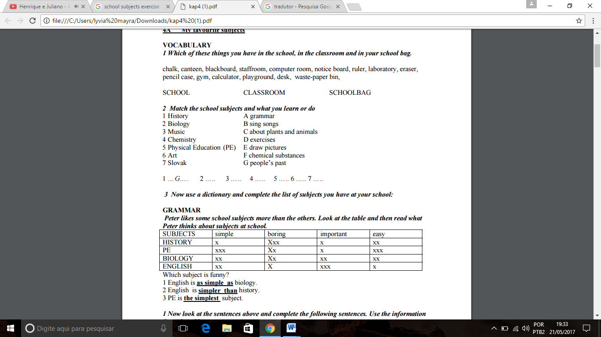

33- Match subjects with the things you use for these subjects. (Ligue as disciplinas com as coisas que você usa para essas disciplinas.)

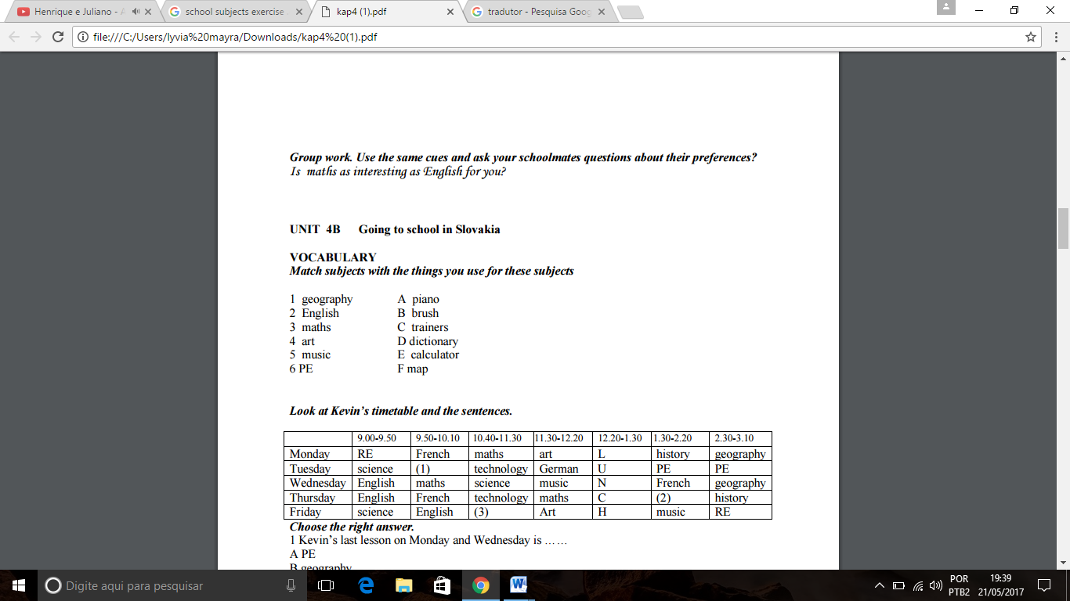

34- Share the information and try to complete the family tree below: (Compartilhe a informação e tente completar a árvore genealógica abaixo:)

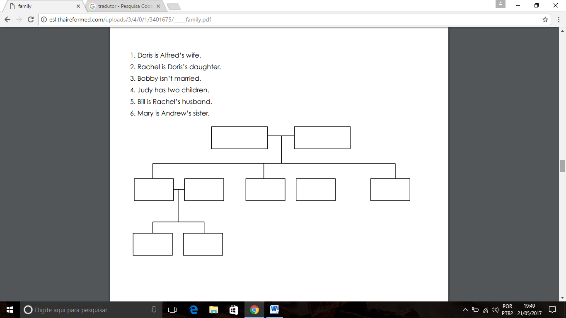

35- Complete Lamar´s Family Tree. (Complete a família do Lamar.)

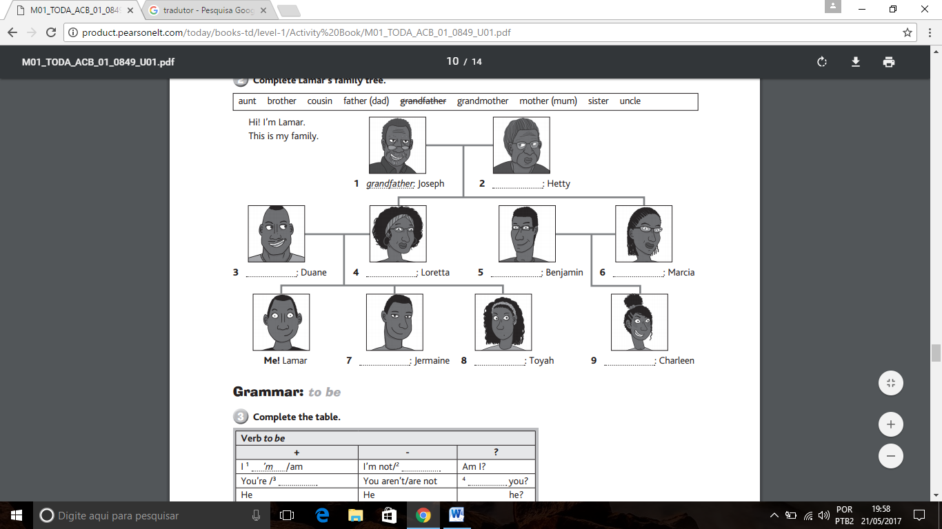

36-Complete the sentences using the articles a or an (Complete as frases utilizando o artigo a ou an .)

a) She has _____ white dog  
b) He want _____ piece of that cake  
c) I love to eat ___ apple every morning  
d) She has ____ interesting idea  
e) My dad got ___ new job  
f) Sarah wants to be ___ dancer

37- Connect the columns taking the articles into account. (Ligue as colunas levando em conta os artigos.)

a) The elephant has a     ( ) Brazilian boy  
b) Our city has a            ( ) engineer  
c) I met a                      ( ) long trunk  
d) Her boyfriend is an     ( ) university  
e) Do you like to be an    ( ) insect?  
f) Is she afraid of an      ( ) animal?  
g) Does he has an          ( ) actor?

38- Complete the sentences with the terms below:

(Complete as frases com os termos abaixo:)  
A – AN – A – AN – AN – A – AN – A

a) Lucy has ___ dog.  
b) Ben bought ___ old bike.  
c) It’s ___ honor to meet ___ smart girl like you at my home.  
d) John is ___ honest boy.  
e) We have ___ hour until the exam.  
f) She is __ university teacher  
g) He is __ British guy

39- Complete the sentence with the correct pronoun: (Complete as frases com o pronome correto:)

a) ____ is my house. (This – Those)  
b) ____ are my friends. (These – That)  
c) Is ____ your backpack? (This – These)  
d) I do not like _____ pencils. (These – That)  
e) I want _____ pants. (This – Those)

40- Complete the sentences: (Complete as frases:)  
**That – These – Those – This – Those – These**

a) ____ are my grandfather and my grandmother. (Perto)  
b) I will buy a dress and ____ skirt. (Longe)  
c) _____ are my parents. (Longe)  
d) Are _____ your friends? (Longe)  
e) _____ is my new car. (Perto)  
f) I gave to my mother _____ flowers. (Longe)

41- Read and complete the chart: (Leia e complete o gráfico:)

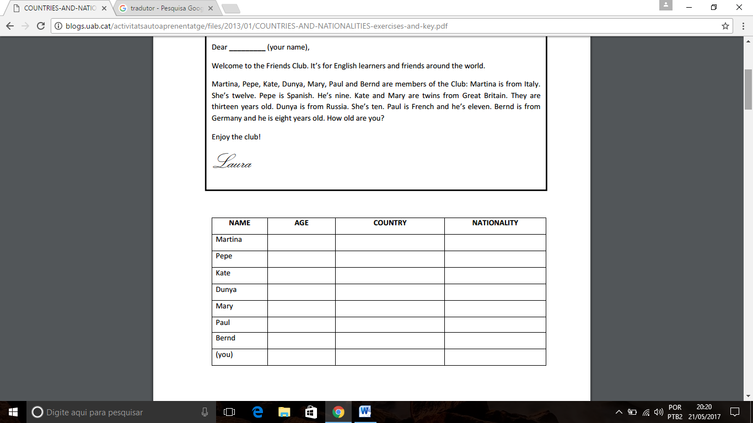

42- Circle the correct word. (Circule a palavra correta:)

a) Carlos is from Spain/ Spanish.

b) She is France/French.

c) Anja is from Russia/Russian.

d) These are my friends from German/Germany.

e) Hina is from Japan/Japanese.

f) Sofia is Greece/Greek.

43- Rewrite the sentences. Use the words in brackets. (Reescreva as sentenças. Use as palavras entre parênteses:)

a) You are Michael. (name)

Your name is Michael.

b) She is from France (French). –

___________________________________________________________________________.

c) Where are you from? (Nationality) –

___________________________________________________________________________.

d) What nationality is she? (from) - ___________________________________________________________________________.

e) Is Susan Spanish? (from) - ___________________________________________________________________________.

f) They are from Poland. (Polish) –

___________________________________________________________________________.

44- Circle the uncountable nouns: (Circule os nomes incontáveis:)

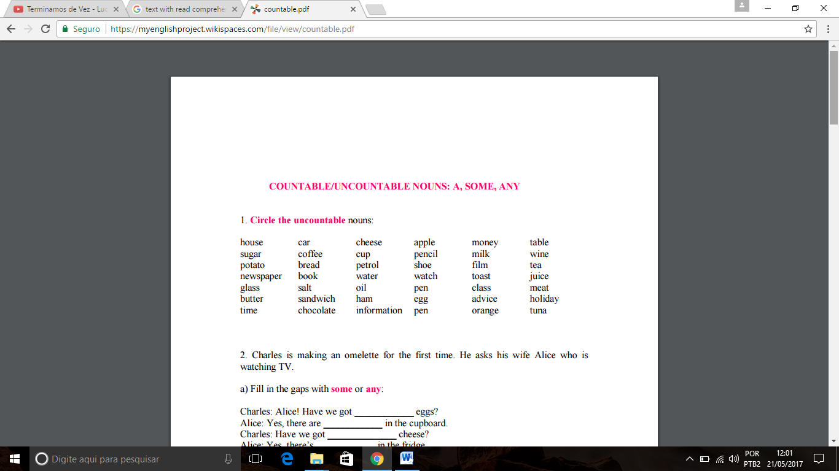

45- The sentence “There is a mistake in your exercise” in the plural is: (A sentença “There is a mistake in your exercise” é:)

a) There is not a mistake in your exercise.

b) There is many mistakes in your exercises.

c) There are many mistakes in your exercises.

d) There to be many mistakes in your exercices.

46- Give the plural of these nouns: (Dê o plural destes substantivos:)

Boy – Girl – ___________________

Book – Pencil –__________________

Mother – Father –__________________

Child – Man – ___________________

Woman – Baby –___________________

Box – Tax –____________________

Ax – Lunch –__________________

Dish – Branch –_________________

Wife – Wolf –___________________

Knife – Self –____________________

Use the verb in brackets to fill the gaps. (Use os verbos em parênteses para preencher os espaços:)

|  |
| --- |
| 47- Affirmative sentences. |
| |  |  | | --- | --- | | 1 | I ________ in Godella.(to live) | | 2 | Daisy________  chocolate.(to love) | | 3 | Andy ________ too fast.(to drive) | | 4 | We ________ lunch at two.(to have) | | 5 | You ________ great.(to look)  **4**8- Add s / es / ies to the following verbs: (Adicione s/es/ies nos verbos a seguir:)  1. do ____________ 8. worry____________  2. study ____________ 9. play ____________  3. teach ____________ 10. grow ____________  4. say ____________ 11. watch_____________  5. cry ____________ 12. miss ____________  6. dance ____________ 13. hurry ____________  7. fix ____________ 14. stop ____________  49- **Fill in: Am / Is / Are / Do / Does: (Preencha com Am/ Is/ Are/ Do/ Does☺**  1. What ____________ your name?  2. Where ____________ you learn?  3. ____________ you a good pupil?  4. How old ____________ you?  5. ____________ you have many friends?  6. What ____________your father do?  7. ____________ your mother work?  8. Who ____________ your best friend?  9. ____________ you a happy person?  10. Why ____________ you looking at your watch?  11. ____________ I asking too many questions  50- B) Rewrite the sentences below in the interrogative and negative forms: 1) John drives his father's car. __________________________________________________________ (interrogativa) _______________________________________________________________________ (negativa)  2) They work from Monday to Saturday. ____________________________________________________________________(interrogativa) ____________________________________________________________________­­­____(negativa)  3) She needs help. ____________________________________________________________________ (interrogativa) _______________________________________________________________________ (negativa) 4) We study at night. ____________________________________________________________________ (interrogativa) _______________________________________________________________________ (negativa) | | |