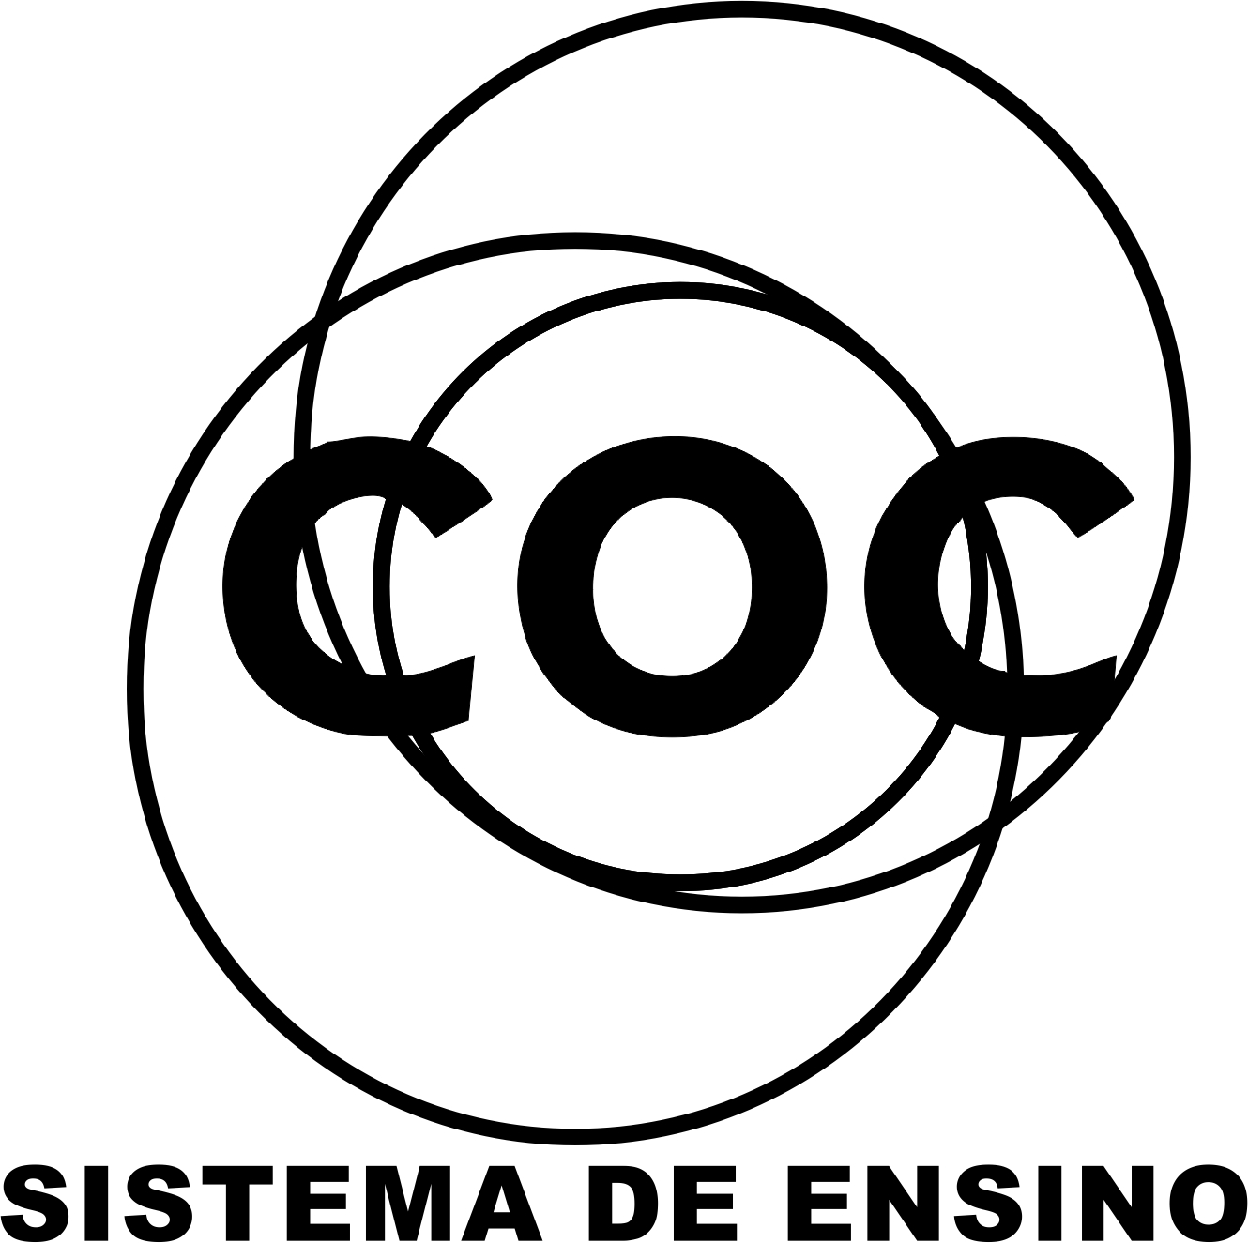

DATA DA ATIVIDADE: / / 2017

PROFESSOR (A): LIVIA

ATIVIDADE DE RECUPERAÇÃO - INGLÊS

SÉRIE: 4º ANO
ALUNO (A): Nº:

TURMA:
NOTA:

2 BIMESTRE

AT THE DOCTOR´S
Doctor: What´s wrong Mary?
Mary: I am sick, I have a headache and a fever. I have a cough and sore throat, too. I think I have a ________________________________.
Doctor: Take this medicine Mary.
Mary: Ok, doctor. Goodbye.

1- The illness´s name that complete the text is: (O nome da doença que completa o texto é:
a) cold
b) cough
c) fever
d)earache
e) headache
2- I am sick, I have high temperature and body ache. I have been all day in the bed because it. I think I have a:________________________________. ( Eu estou doente, tenho a temperatura alta e dor no corpo. Eu estive o dia todo na cama. Eu acho que eu tenho uma:___________________________):

3- Look the picture and choose the correct word: ( Olhe a imagem e escolha a palavra correta:)

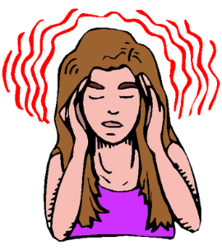She has a _________________________.

a) cold
b) cough
c) fever
d)earache
e) headache

4- Name this parto f the body. (Nomeie cada parte do corpo: )

-
______________________ ___________________ _________________________

5- Where is my mouth? (Onde fica a minha boca?)
____________________________________________________________________________________________________________________________________________
6- What´s missing in the boy?

7 Put the parts of the body name: (Ponha os nomes das parts of the body:)
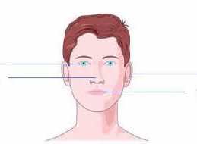
8- Choose the correct words to complete the sentence: (Escolha a correta palavra para completar a sentença:)
(toothache - backache - headache - sore throath - fever - cold - earache)
a) 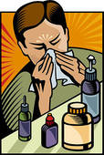 b) 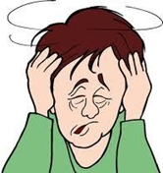
He has got a____________________. He has got a ____________________.

c) 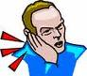 d) 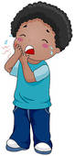
He has got a ___________________. He has got a _______________________.
Medicine
Vocabulary: Medicine - drug grocery - “over the counter” - generic brand - expensive .
You are sick. You need medicine. Medicine is a drug. It helps your body get better.
You buy medicine at the grocery store or the drug store. It is an “over the counter” drug. You do not need a doctor’s note.
You buy medicine that is cheap. The store sells a “generic brand.” It is less expensive than a name brand.

9- Circle the correct word. Write the word.
1. You are sick. You need ____________ (medicine/money).
2. Medicine is a ___________ (cold/drug).

3. You buy medicine at the __________ (grocery/clothes) store.
4. You buy an “_______ (under/over) the counter” drug.
5. You buy medicine that is ________ (expensive/cheap).
6. The store sells a ____________ (generic/name) brand.

10- Match the word and the definition:
1. Medicine a. helps you get better
2. Over the counter b. store sells a cheap drug
3. Drug c. a kind of drug
4. Generic brand d. buy medicine at the store

