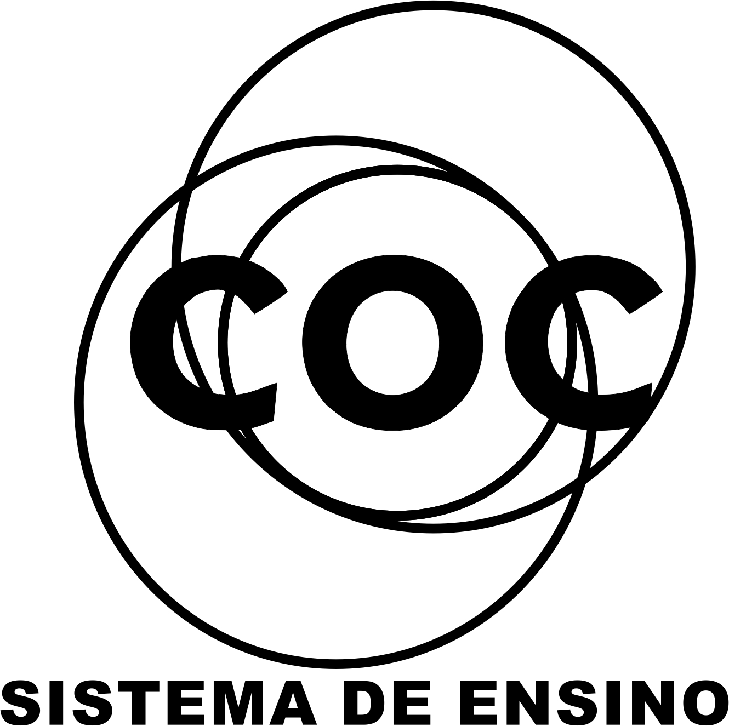

DATA DA ATIVIDADE: / / 2017

PROFESSOR (A): IRLANA

ATIVIDADE DE RECUPERAÇÃO – CIÊNCIAS NATURAIS

SÉRIE: 5º ANO
ALUNO (A): Nº:

TURMA:
NOTA:

1.Como são chamados os seres que precisam se alimentar de outros seres vivos?
________________________________________________________________________________________________________________________________________________________________________________________________________________________________________________________________________________________________________________________
2.Como são definidos os seres autótrofos?
________________________________________________________________________________________________________________________________________________________________________________________________________________________________________________________________________________________________________________________
3.Onde podemos encontrar os nutrientes adequados para a nossa vida ?
________________________________________________________________________________________________________________________________________________________________________________________________________________________________________________________________________________________________________________________
4.Existem diferentes tipos de nutrientes ,quais são eles?
________________________________________________________________________________________________________________________________________________________________________________________________________________________________________________________________________________________________________________________
5.Como podemos classificar os alimentos que possuem variados nutrientes?
________________________________________________________________________________________________________________________________________________________________________________________________________________________________________________________________________________________________________________________
6.Quais tipos de alimentos são construtores?
________________________________________________________________________________________________________________________________________________________________________________________________________________________________________________________________________________________________________________________
7.Onde podemos encontrar os alimentos reguladores?
________________________________________________________________________________________________________________________________________________________________________________________________________________________________________________________________________________________________________________________

8.Como previnimos o raquitismo?
________________________________________________________________________________________________________________________________________________________________________________________________________________________________________________________________________________________________________________________
9.A vitamina A é muito importante para a visão ,quais são esses alimentos ?
________________________________________________________________________________________________________________________________________________________________________________________________________________________________________________________________________________________________________________________
10.Qual a função da vitamina C?
________________________________________________________________________________________________________________________________________________________________________________________________________________________________________________________________________________________________________________________

