DATA : / / 2016

PROFESSOR (A): TÂNIA
LISTA DE EXERCICIO PARA RECUPERAÇÃO DE INGLÊS

SÉRIE: 7º ANO
ALUNO (A): Nº:

TURMA:
NOTA:

3º BIMESTRE

Read the following text to answer the questions below.
A day In the life of a Brazilian student
My day starts very early. I get up at six o'clock in the morning. I have breakfast at half past six . After breakfast , I go to school but I don't take a bus. I walk to school, because we live near it. I start school at seven o'clock. I stay there until noon. After school, I go home and I have lunch. After lunch I study and I do my homework. At five o'clock I take a shower. At seven o'clock all my family is at home and we have dinner together. We talk about our day . After dinner , we watch TV or listen to good music. I don't go to bed very late. I go to bed before ten o'clock.
1. Reescreva o texto acima colocando o sujeito na terceira pessoa do singular.
Her day starts very early. She____________________________________________________________________________________________________________________________________________________________________________________________________________________________________________________________________________________________________________________________________________________________________________________________________________________________________________________________________

ANSWER THE QUESTIONS ABOUT THE TEXT.
2. What time does she have breakfast?
3. How does she go to school? Why?
4. What does she do after lunch?
5. What time does she have dinner?
6. What time does she go to the bed?
LOCALIZE OS SEGUINTES VERBOS NO TEXTO.
7. COMEÇAR
8 LEVANTAR
9. IR
10. PEGAR
11. ANDAR
12. VIVER/MORAR
13. FICAR
14. ESTUDAR
15 FAZER
16. CONVERSAR
17 ESCUTAR
18. JANTAR
RETIRE DO TEXTO AS SEGUINTES FRASES EM INGLÊS

19. Meu dia começa muito cedo.
20. Às cinco horas eu tomo banho.
21. Eu não durmo muito tarde.
22. Eu não vou para a escola de ônibus.
23. Após o almoço eu estudo e faço tarefa de casa.
24. Nós conversamos sobre o nosso dia.
25. Eu vou para a escola a pé.

WRITE THE INTERROGATIVE FORM OF THE SENTENCES.

26. Raphael is having dinner.
27. Ellen is playing soccer now.
28. My brother is going to the bank on week days.
29. Marcelo is reading magazines.
30. Children are having milk for breakfast.
31. Those kids are writing their names on the board.
32. I am watching good movies on TV.
33. Mary is loving her new job.

WRITE THE NEGATIVE FORM OF THE SENTENCES.
34. Raphael is having dinner.
35. Ellen is playing soccer now.
36. My brother is going to the bank on week days.
37. Marcelo is reading magazines.
38. Children are having milk for breakfast.
39. Those kids are writing their names on the board.
40. I am watching good movies on TV.
41. Mary is loving her new job.

DE ACORDO COM A FIGURA DESCREVA ONDE ESTÃO O GATO E O PÁSSARO USANDO AS PREPOSITIONS OF PLACE.
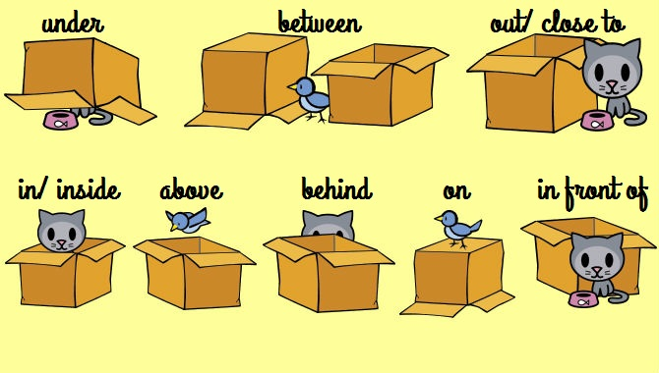
42
43
44
45
46
47
48
49
50

