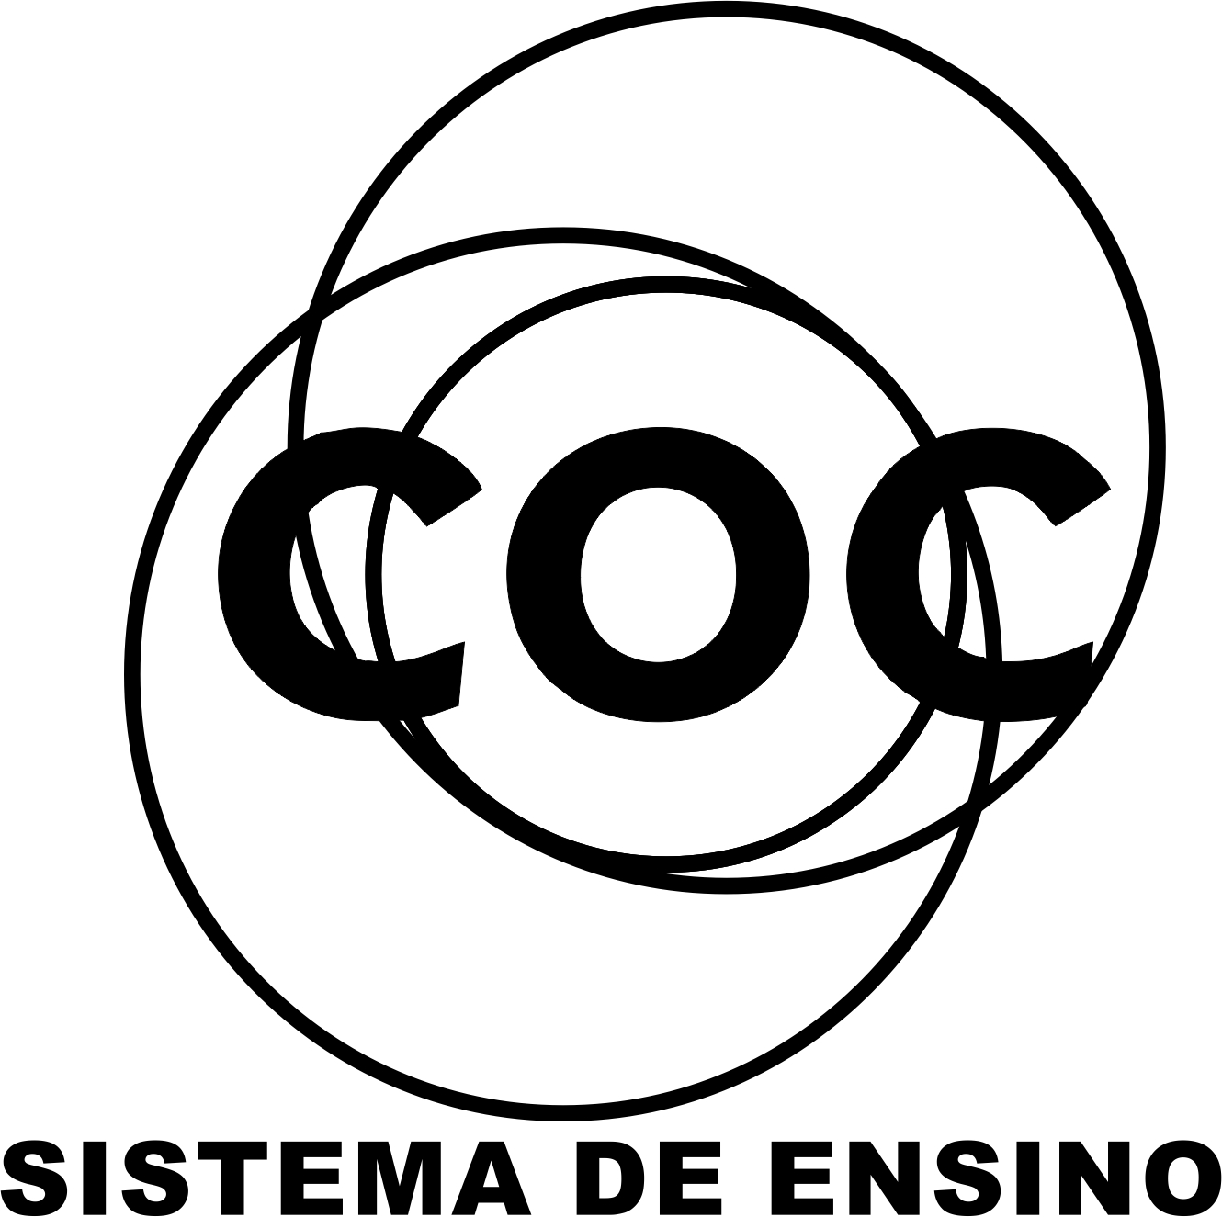

DATA DA PROVA: / / 2015

PROFESSOR (A): ANA PAULA
BANCO DE QUESTOES INGLÊS

SÉRIE: 8º ANO
ALUNO (A): Nº:

TURMA:
NOTA:

4º BIMESTRE

- Reflexive Pronouns

31. Write the Reflexive Pronouns.
Subject Pronouns Reflexive Pronouns
________ ________________________
________ ________________________
________ ________________________
________ ________________________
________ ________________________
________ ________________________
________ ________________________
________ ________________________

32. Use the Reflexive Pronouns.

a) Bianca behaves ________________________in the party.
b) My brother hurt________________________on the floor.
c) My little sister can’t wash________________________.
d) I cut______________________

33. Circle the correct answer.
e) The girls look ______________________at the mirror. ( themselves / herself )
f) Carla and I hurt______________________ with a knife. ( herself / ourselves )

34. (ITA) As I was sure that I couldn't ask anybody for help, I wrote the letter by __________.
a. yourself
b. myself
c. himself
d. itself
e. themselves
35. Mark the correct alternative.
- It’s too hot in here. Let’s refresh _________ with a drink of cold water.
a. myself
b. yourself
c. yourselves
d. ourselves
e. themselves

36. Choose the correct option.
- You usually looks at........in the mirror.
a. herselves
b. herself
c. yourself
d. himself
e. themselves

- Laura used to cut............at work.
a. himself
b. ourselves
c. herself
d. yourselves
e. themselves

37. It is programmed to close............at night.
a. himself b. Its
c. Itselves d. myself
e. itself
38 . Choose the correct option.
a) I cut_______ with a knife the other day and Carol hurt _______ .
a) yourself – himself b) myself – himself
c) myself – herself d) themselves – myself
b) The girl look________ in the mirror !
a) themselves b) himself c) herself d) myself
39. Conjugate the verb work in the Present Perfect Continuous.
Affirmative Interrogative
_______________________________ ____________________________
_______________________________ _____________________________
_______________________________ ____________________________
_______________________________ _____________________________
_______________________________ ____________________________
_______________________________ _____________________________
_______________________________ ____________________________
_______________________________ _____________________________

40. Write the sentences in the short form.
a) I have been playing football this week. _________________________________________
b) She has been fixing the car.__________________________________________________

41. Make the present perfect continuous.
a) (she / work here for five years)
___________________________________________________________________
b) (I / study all day)
____________________________________________________________________

42. Make negative sentences in the Present Perfect Continuous.
a) (you / eat a lot recently)
_____________________________________________________________________
b) (we / live in London for six months)
________________________________________________________________________
43.Make Interrogative sentences in the Present Perfect Continuous.
a). (he / play football so he’s tired)
________________________________________________________________________
b). (they / learn English for two years)
_________________________________________________________________________
44.. Correct the mistakes.
a)I has been cooking so I’m really hot._____________________________________
b) She has going to the cinema every weekend for years._______________________
c) It has been rain, the pavement is wet.______________________________________
d) You have been sleeping for twelve hours?__________________________________
- Second Conditional
Forma: If + simple past + would + verbo

45. Choose the correct answer
a) If I had enough money I____________________ a big house. ( would buy / bought )
b) If we ______________ in Mexico, I would speak Spanish. ( lived / would live )
c) We would buy a house if we _______________to stay here. ( decided / would decide)
d) She_______________the exam if she studied more. ( passed / would pass )

46.If I had more free time , I ................................. my room. (tidy)

a) would tidy b) will tidy

47. If he ......................... about it, I'd definitely give him some present. He's my best friend! (forget)

a) would forget b) forgot

48. Rewrite the sentences and use the second conditional.
- Example : My car is out of order. I won't drive you there.
If my car wasn't out of order, I would drive you there.

a) He doesn't like tomatoes. He won't eat the salad.
If he ...................... tomatoes, he ....................... the salad.

b) You aren't lucky. You will not win.
If you ...................... lucky, you .......................

49.Complete this sentence.
a) I will travel.
b) I traveled.
c) I would travel.
50. Circle the sentences in the Second Conditional.

