DATA DA PROVA: / / 2015

PROFESSOR (A): ANA PAULA
BANCO DE QUESTOES INGLÊS

SÉRIE: 7º ANO
ALUNO (A): Nº:

TURMA:
NOTA:

4º BIMESTRE

Comparative and Superaltive

- COMPARATIVE

26. Short Adjectives ( adjetivos curtos )
Forma: adjetivo + er + than

Ex. Use the Comparative of the adjectives in parentheses.
- You are ___older than me. ( old )
- My cellphone is________________________Paul . ( small )
- Her book is___________________ ours. ( big )
- Susan is _____________________Jane . ( happy )

27. Long Adjectives ( adjetivos longos )

Forma: more + adjective + than
( mais ) ( que )

Ex. Use the Comparative of superiority of the adjectives in parentheses.
- A car is______________________________a bike. ( expensive )
- Tom is _______________________________Jack . ( intelligent )

28. Complete the sentences with the COMPARATIVE.
a) Mary is ______________________________Carol. ( quiet )
b) Brad Pitt is_________________________________Bruce Willis. ( young )
c) A dictionary _________________________________a magazine. ( interesting )
d) Chinese is _____________________________________Portuguese. ( difficult )
e) This table is____________________________________that one. ( bad )
f) Curitiba is_______________________________________Macapa. ( good )
g) Brazil is___________________________________________Japan. ( hot )
h) A car is__________________________________________bike. ( heavy )
i) A lion is___________________________________________a cat. (dangerous )
j) Mike is___________________________________________Tom.( handsome)

29. Write the comparatives of these adjectives. Look the example.
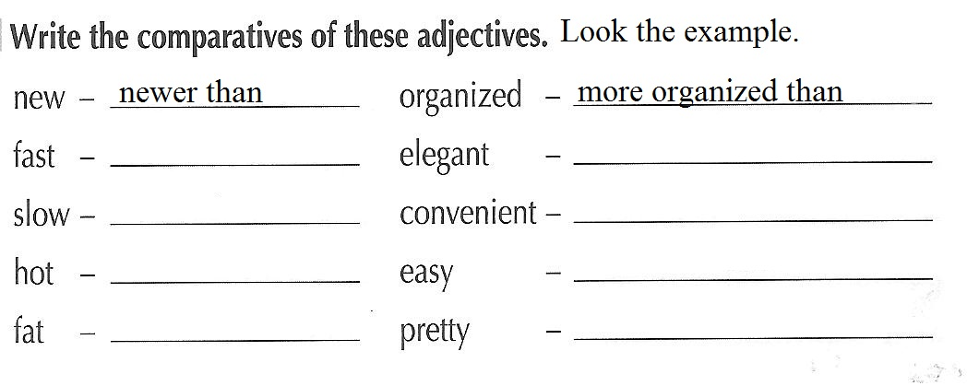

30. Translate these sentences.
a) Ana is stronger than Carol.___________________________________________
b) Math is more difficult than Art._______________________________________
c) Bia is happier than Jane._____________________________________________
31.Rewrite the sentences in the correct order.

a) Robin / intelligent / more / Jane / is / than.
_______________________________________________
b) is / Peter / than / older / John.
_______________________________________________

32.Correct the mistakes.
a) John is old than Mike.
______________________________________________________
b) Debby is more tall than Carol.
______________________________________________________
c) Zack is intelligenter than Mark.
______________________________________________________

33. Write in English.
- Mary é mais rica que Jane.
_____________________________________________________________
b) O tigre é mais perigoso que a zebra.
______________________________________________________________
c) David é tão alto quanto Diego.
_______________________________________________________________

- SUPERLATIVE
34. Short Adjectives

Forma: the + adjective + est

Example: Complete the sentences with the Superlative of the adjectives.
- My mom is the kindest person in my family. ( kind )
- Jane is____________________________ person in my group. ( lazy )
- David_________________________boy in the classroom. ( tall )

35. Long Adjectives .

Forma: the most + adjective

Example : Complete the sentences with the Superlative of the adjectives.

a) My uncle has_________________________car in my family. ( expensive)
b) Billy is ___________________________person that I know.( interesting )
c) Marta is___________________________girl in that group. ( generous )

36. Use the Superlative.

a) I think Science is _______________________________subject at school. (interesting)
b) I went to ______________________restaurant in the world. ( bad )
c) I watch _______________________show of Jota Quest yesterday. ( good )
d) Paul is_________________________boy I know.( quiet)
e) My bag is___________________________of the classroom. ( big )

37. Write the superlative of the adjectives below.
a) happy___________________________________
b) dangerous________________________________
c) tall______________________________________
d) hot______________________________________

38. Existem adjetivos que possuem forma IRREGULAR de Comparativo e Superlativo.

Comparative Superlative
good ( bom ) better than ( melhor que) the best ( o melhor )
bad ( ruim ) worse than ( pior que ) the worst ( o pior )

Example 1: Use the Comparative.
- A bed is___________________________the floor. ( good)
- Your letter is _______________________mine. ( bad )

Example 2: Use the Superlative.
- David has __________________________sneakers ( good)
- My grade was _______________________in math. ( bad )

- COMPARATIVO OU SUPERLATIVO?

39. Write ( C ) to Comparative and ( S ) to Superlative.
( ) Joanne is thinner than Priscila.
( ) Cheetahs are the fastest animals in the world.
( ) Albert Einstein was the most intelligent scientist.
( ) Jane is the best person that I know.

40. Mark the correct option. Pay attention !
1. Jane is______girl in her class. 2. Brazil is _____ Argentina.
a) the most beautiful a) the biggest
b) more beautiful than b) bigger than

3. December is______July in Brazil. 4. São Paulo is____city in Brazil.
a) hotter than a) larger than (large =grande)
b) the hottest b) the largest

41. Mark the correct option.
a) Brad Pitt is_________________________________Bruce Willis. ( young )

( ) more younger than ( ) younger than

b) A dictionary _________________________________a magazine. ( interesting )

( ) interesting than ( ) more interesting than

c) This table is___________________ _________________that one. ( bad )

( ) badder than ( ) worse than ( ) more bad than

d) Curitiba is_______________________________________Macapa. ( good )

( ) better than ( ) gooder than ( ) more good than

e) Brazil is___________________________________________Japan. ( hot )

( ) hoter than ( ) hotter than ( ) more hotter than

f) Brazil is _________________country in South America. ( big )

( )the most big ( ) the biggest ( )the most biggest

g) My brother is __________________ boy in my family. ( lazy )
( ) the most lazy ( ) the laziest ( ) the laziest

42. Correct the mistakes.
a) A bike is the cheappest than a car. ( cheap )
_________________________________________________________________

b) Brazil is the bigest country in South America. ( big )
_________________________________________________________________
c) Mary is the most old in my family. ( old )

43. Write ( C ) to correct sentences and ( I ) to incorrect sentences about the COMPARATIVE and the SUPERLATIVE.
( ) Tom is more quiet than Fred.
( ) Anaconda is one of the largest snakes in the world.
( ) A car is expensiver than a bike.
( ) Susy is the most intelligent than Martha.
( ) My mom is the most generous in my family.

44. Choose the correct alternative.

a) A bed is______________________ the sofa . ( good )
( ) gooder than
( ) better than

b) Dogs are _______________________cats . ( interesting )
( ) the most interesting
( ) more interesting than

c) The yellow bike is______________________. ( cheap )
( ) the cheapest
( ) cheaper than

45. Match the columns.
( a ) bad ( ) the smallest
( b ) modern ( ) the worst
( c )small ( ) the best
( d )good ( ) the slimmest
( e ) slim ( ) the most modern
46. Choose the correct answer in the box.
( Escolha a resposta correta dentro da caixa)

the oldest slower than
more expensive the most intelligent

a) A turtle is ________________________ a lion.
b) A Ferrari is ___________________________a BMW.
c) Albert Einstein is ___________________________scientist.
d) My grandmother is ____________________________in my family.

47. Complete :

Comparative Superlative
GOOD __________ ___________
BAD __________ ___________

48. Choose the correct alternative.

a) Sofa is _______________________desk .
( comfortabler than / more comfortable than )

b) Jane is______________girl in my family.
( the oldest / older than)

49. Write ( C ) to Comparative and ( S ) Superlative.

( ) My bedroom is cleaner than yours.
( ) Jack has the best car in my family.
( ) Tom is more intelligent than Mike.
( ) Sara is the most generous in my group.

50. Mark the correct superlative.

a) bad ( ) the worst ( )the baddest
b) modern ( ) the modernest ( ) the most modern
c) small ( ) the smallest ( ) the most small
d) good ( ) the best ( ) the goodest
e) hot ( ) the hottest ( ) the hotest

