DATA DA PROVA: / / 2015

PROFESSOR (A): ANA PAULA
BANCO DE QUESTOES INGLÊS

SÉRIE: 6º ANO
ALUNO (A): Nº:

TURMA:
NOTA:

4º BIMESTRE

Future with “ going to”

28. Complete the sentences with “ going to ”.
a) I____________________________________my room. ( clean )
b) He__________________________________ to some music. ( listen )
c) Joseph__________________________________ a movie. ( see )
d) The boys___________________________________TV. ( watch )

29. Rewrite the sentences.

a) Tom is going to meet his parents tonight.
Int.:________________________________________________________________

b) You are going to travel to Paris.
Int.:________________________________________________________________

30. Mark the correct alternative. The sentence “ She is going to travel to Paris.” means:

a) Ela viajou para Paris. c) Ele vai viajar para Paris.
b) Ela vai viajar para Paris. d) Ela está viajando para Paris.

31. Mark the option with the correct order . ( Marque a opção com a ordem correta da frase)

- Mary is going to play soccer?
- Mary is going to not play soccer.
- Is not play Mary going to soccer?
- Mary is going to soccer play.
- Mary is going to play soccer.

32. The sentence “ Nós não vamos jogar cartas.”in English is:

a) They are not going to play cards.
b) We are not going to play cards.
c) We are going to play cards.
d) You are not going to play cards.

33. Write ( C ) to correct sentences and ( I ) to incorrect sentences.

( ) They is going to watch TV.
( ) Jonny is going to playing the piano.
( ) I am not going to listen to music.
( ) She is going buy a car.

34. Correct the mistakes. ( mistakes – erros )

a) She is going to watching a movie.___________________________________
b) Melissa going to buy a bike. _______________________________________
c) The boy are going to play cards.____________________________________
d) Mike and Jonh is going to walk in the park.____________________________

35. Match the columns.

( 1 ) They are going to watch… ( ) a car.
( 2 ) Jonny is going to play… ( ) TV.
( 3 ) I am not going to listen… ( ) shower.
( 4 ) Debby is going to buy… ( ) music.
( 5 ) That boy is going to take… ( ) the piano.
36.Write the sentences in the correct order.

a) going / I / to / am / visit / mother / my
_______________________________________.
b) restaurant / is / Mary / to / going / the.
_______________________________________.
c) are / they / to / play / the / going / not / basketball
_______________________________________.

37. Complete the sentences with the verbs in the box. Use the future with going to.

fly play study see read

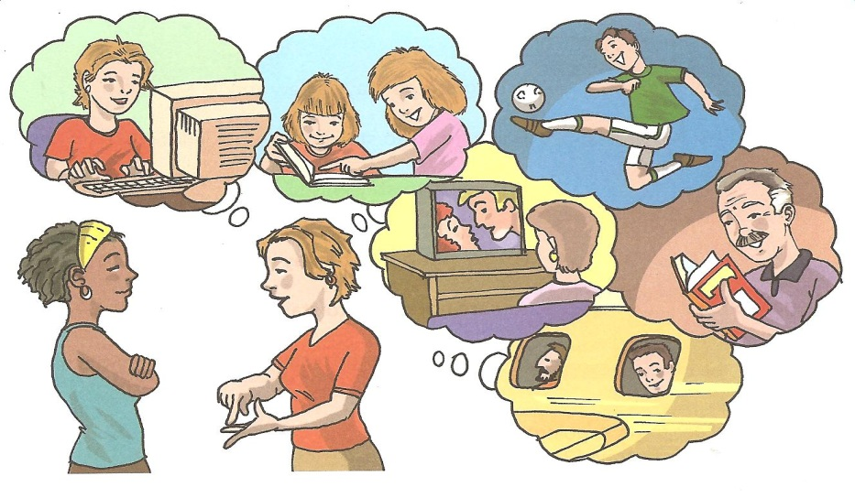
- The girls________________________________English.
- Victor ___________________________________soccer.
- William is going to fly to Los Angeles.
- My mother _____________________________a movie.
- My father ___________________________a book.

38. Rewrite the sentences.

a) Kelly is going to meet his parents tonight.
Neg.:________________________________________________________________

b) They are going to travel to Italy.
Neg.:________________________________________________________________

39. Conjugate the verb to travel in the Future with “ going to ”

Affirmative

Forma: Suj. + to be ( am ,are ,is ) + going to + verbo

_______________________________________
_______________________________________
_______________________________________
_______________________________________
_______________________________________
_______________________________________
_______________________________________
_______________________________________

40. Write :
Subject Pronouns Object Pronouns
__________ _________
__________ _________
__________ _________
__________ _________
__________ _________
__________ _________
__________ _________
__________ _________

41. Write:
(SP) Subject Pronoun
(OP) Object Pronoun

(____) They can swim.
(____) She saw me.
(____) John likes her.
(____) You write to them.
(____) Did you like it?

42. Write in the parentheses.
( ) Kelly likes it
( S ) Subject ( ) They are tired.
( O ) Object ( ) She is sad.
( ) You love us.
( ) It likes milk.

43. Mark the Subject pronouns.

- you, she, it, they
- his. he, she, our
- they, us, you, your
- me, us, you, my
- me. I, we, our

44. Substitute the names to: Subject or Object Pronouns.
a) Tom likes Susan.
_________likes _______

b) Kelly talks to my parents.
______ talks to _______

45. Write the subject pronouns in Portuguese.
I__________
You_________
He___________
She___________
It_____________
We____________
You ___________
They___________

46. What is the difference between: Write in Portuguese.

Subject Pronouns:_____________________________________________________________
Object Pronouns:______________________________________________________________

47. Choose the correct option.

Example: I love my father.
I love him.
( x ) him ( ) hi ( ) she

a)I like Carol very much.
I like_______very muc
( ) their ( ) him ( ) her

b)We help the children( crianças).
We help___________.
( ) her ( ) them ( ) his

c) I like my brother.
I like ____________.
( ) He ( ) me ( ) him

48. Substitute the names to: Subject or Object Pronouns.

a) Tom likes Susan. b) My sirter talks to my parents.
_______likes _______ _______ talks to _______

49. Write SUBJECT or OBJECT.

a) Julio likes her.___________________
b) They are tired.___________________
c) I like you. _______________________

50. Mark the Object pronouns.

- you, she, it, they
- his. he, she, our
- they, us, you, your
- me, us, you, me
- me. I, we, our

