Coc recup. 8º
1. Future with going to
1. Complete the sentences with the Immediate future ( Uso do “going to”)
a) I___________________________my room. ( clean )
b) He_____________________________ to some music. ( listen )
c) Joseph____________________________ a movie. ( see )
d) The boys_____________________________TV. ( watch )

2. Rewrite the sentences.
a) Tom is going to meet his parents tonight.
Int.:____________________________________________________
Neg.:___________________________________________________

b) They are going to do their homework.
Int.:____________________________________________________
Neg.:___________________________________________________

3. Correct the grammar mistakes.( Corrija os erros gramaticais de cada sentença )

a) They going to play soccer.
__________________________________________________
b) I am go to listen to music.
__________________________________________________
c) Susan are going to play the guitar.
__________________________________________________
d) You are going to travel by plane ?
__________________________________________________

4. Write ( C ) to correct sentences and ( I ) to incorrect sentences.

( ) They is going to watch TV.
( ) Jonny is going to playing the piano.
( ) I am not going to listen to music.
( ) She is going buy a car.

2. Future with will

5. Complete the sentence with the Simple Future( Future with WILL ).
a) Silvia_________________a house next year. ( buy )
b) Betty __________________to Paris. ( travel )
c) I _____________________soccer for Brazil. ( play )
d) They________________________ a postcard. ( not / write )

6. Rewrite the sentences in the contracted form.

a) They will live in a different place.
___________________________________________________
b) She will not be married.
______________________________________________________

7. Put the sentences in the correct order.

a) to Japan / go / will / not / she.
______________________________________________________
b) They / ? / swim / will / in the lake.
_______________________________________________________

8. Correct the sentences.( Corrija as sentenças )

a)They will playing volleyball tomorrow.
_____________________________________________________
b) I willn’t read the magazine.
_____________________________________________________
c) We will travel to London?
_____________________________________________________
d ) He won’t not buy a car.
_____________________________________________________

9. Rewrite the sentences in the Simple Future.

a) I work at the supermarket.
_______________________________________________________
b) They play handball.
_____________________________________________________

10.Mike ________________________voleyball next year. ( play )
( ) will play ( ) play will ( ) will playing

11. ______________buy a house tomorrow?
( ) Will she ( ) She will ( ) Will

12.They_______________work in the Bank next month.
( ) willn’t ( ) won’t ( ) not will

13. My mother will_________________ to Rio de Janeiro.( travel )
( ) will travel ( ) travel ( ) traveling

14. Mary___________________at the club. ( work)
( ) will works ( ) will to work ( ) will work
15. The boy_______________________at home at night. ( arrive )
( ) will arrive ( ) will arrives ( ) will to arrive
16. Write ( C ) to correct sentences and ( I ) to incorrect sentences. ( 1.0)
( ) She will be an actor ?
( ) My brother will to watch TV.
( ) We’ll travel in spacecraft.
( ) The girls will go to the party.
( ) She won’t be at home early.

17. They_______________work in the Bank next month. ( work )
a) willn’t b) won’t c) not will d) won’t not
18. Gabriel ___________________ a new car next year. ( buy )
a) will to buy b) buy will c) will buys d) will buy

3 . Present Perfect Tense

19. Write sentences . Use the Present Perfect Tense.
a) Susan / to go / to the park.
____________________________________________________________________________
b) The boys / to see / an accident.

20. Write the verbs in the Participle.
IRREGULAR VERBS
Infinitive Past Participle Translation

- To leave______________________________
- To read______________________________
- To see_______________________________
- To go________________________________
- To be________________________________
- To buy_______________________________
- To drink _____________________________
- To drive______________________________
- To do________________________________
- To swim______________________________
- To meet______________________________
- To sleep_____________________________
- To have______________________________
- To write______________________________
- To find_______________________________
REGULAR VERBS
Infinitive Past Participle Translation

1.To arrive________________________________
2. To stay________________________________
3. To study _______________________________
4.To play_________________________________
5.To clean________________________________
6. To open________________________________
7. To close________________________________
8.To visit_________________________________
9. To cook________________________________
10. To stop_______________________________
11. To live________________________________
12. To dance______________________________
13.To work _______________________________
14. To talk________________________________
15.To listen ______________________________

21. Complete the sentences with Present Perfect Tense of the verbs in parentheses.
a) I______________________their house. ( to clean )
b) He____________________ to the park. ( to go )
c) The girls _________________________ their schoolbags. ( to find )
d) My father ________________________late recently. ( to arrive )
22. Rewrite the sentences.
a) They have been to London.
Int.:_______________________________________

b) She has found her book.
int.:______________________________________

23. Rewrite the sentences.
a) Susan have been in Paris.
Neg..:_______________________________________

b) She has found her ring.
neg.:______________________________________
24. Correct the mistakes.
a) We have find an umbrella.
______________________________________________.
b) The girls has invited their friends.
______________________________________________.
c) He has gone to the park ?
______________________________________________.
d) My brother have washed his bike lately.
______________________________________________.

25. Put the sentences in the correct order.

a) lately / have / they / Australia / to / gone / ? .
_________________________________________________
b) not / has / Mike / TV / watched / recently .
_________________________________________________

26. Rewrite the sentences in the short form / contracted form.
I have not______________ We have_________________
She has________________ It has___________________
You have_______________ They have_______________
He has not______________ You have not_____________

27. Correct the mistakes.
a) Tom has be angry._____________________________________________
b) The boys has read magazines.____________________________________
c) She has slept a lot ? ___________________________________________
d) I has bought many candies.______________________________________

28. Complete the blanks with has or have.

- I___________never come to school by subway.
- Mike___________ returned from a week in Cancun.
- Mr. and Mrs. Wilson_____________taught Portuguese.
- ____________Christine and Joe drunk beer?

29. Mark the participle of the verbs:
a) stay b) leave c) read d) see
( ) staied ( ) leaven ( ) read ( ) seen
( ) stayed ( ) left ( ) rode ( ) saw
( ) stayen ( ) leaved ( ) ridden ( ) seened

30. Write ( C ) to correct sentence and ( I ) to incorrect sentence .
( ) We has drunk a lot lately.
( ) The boy hasn’t seen the accident.
( ) Sally haven’t found her dog.
( ) They’ve arrived late at home .
( ) We’s played soccer.

31. Write what these people have done. Use the verbs from the box in the Present Perfect. ( Escreva o que essas pessoas tem feito)
study math - clean the kitchen - go to bed - open the store
Ex.: Josie has watched TV .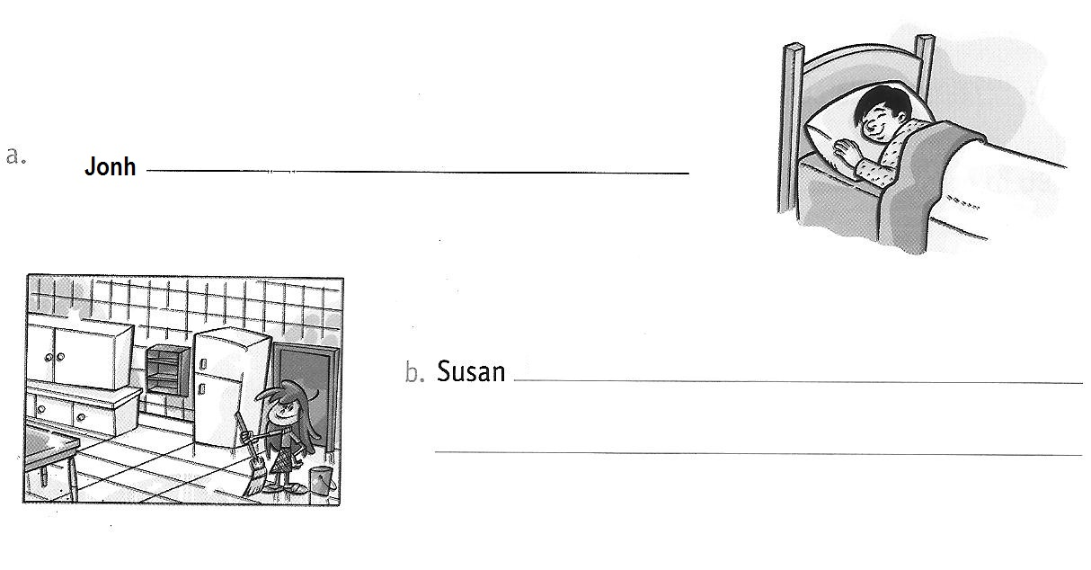
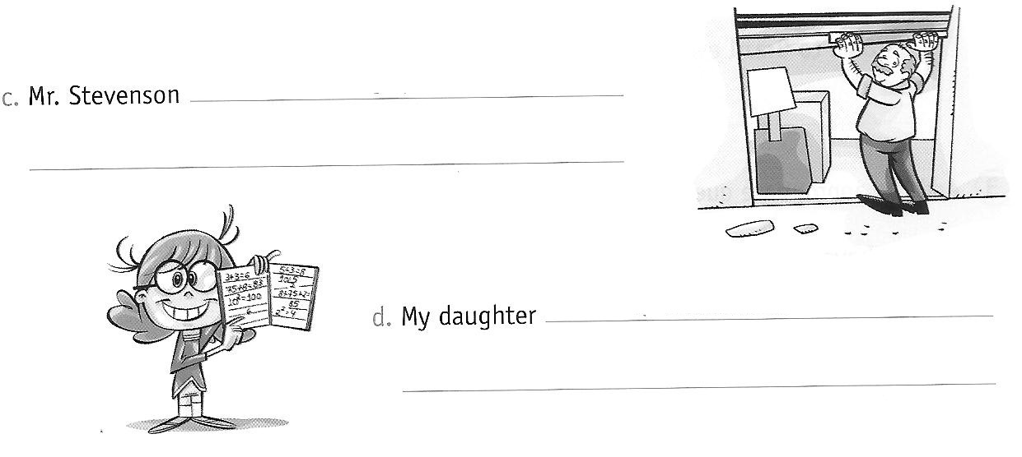

32.Mark the CORRECT sentence in the Present Perfect Tense.
( ) Jonh has driven a Ferrari.
( ) My friends has done their exercises.
( ) Jane has gone to Curitiba last year.

33.Mark the INCORRECT sentence in the Present Perfect Tense.
( ) I have read many books lately.
( ) Louis has swum in the lake.
( ) He has see his daughter lately.

Present Perfect Tense
- Affirmative : Sujeito + has / have + verbo no particípio
- Interrogative: Has / Have + Sujeito + verbo no particípio
- Negative : Sujeito + has / have + not + verbo no particípio

34. Write the sentences in the correct order.
a) cleaned / just / his room / has / David /
______________________________________________________
b) traveled / yet / ? / You / Paris / to / have

35. Rewrite the sentences in the short form / contracted form.
I have not______________ We have_________________
She has________________ It has___________________
You have_______________ They have_______________

36. Complete this dialogue with:

ever never yet just for since

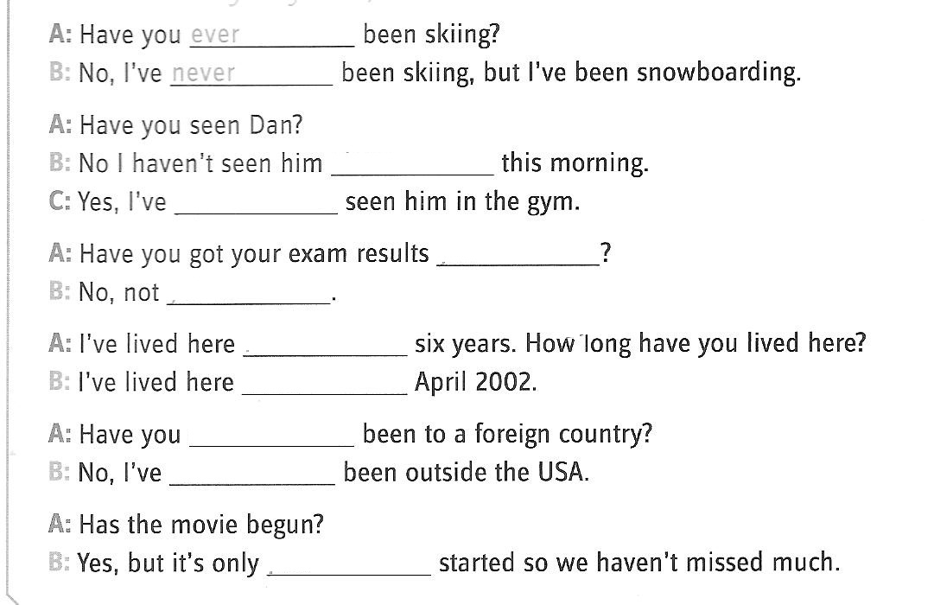

37. Qual é a resposta correta da frase “Have you told him the news?”?
a) Yes, I did.
b) Yes, I do.
c) Yes, I have.
d) Yes, I told.

38. Use since or for.
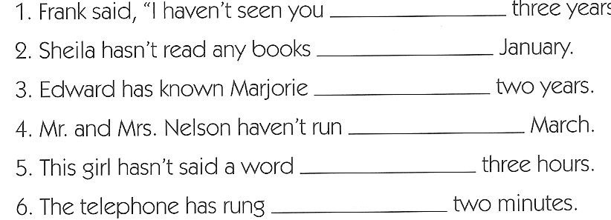

39. Use just , ever .never or yet.

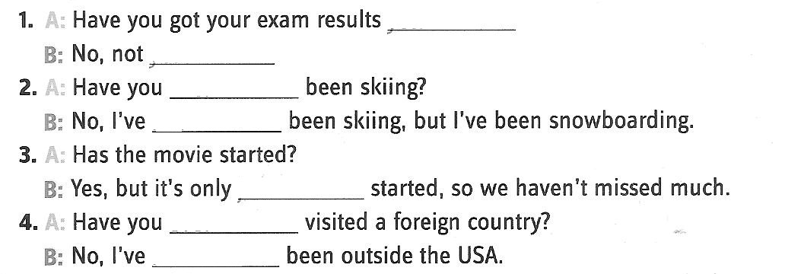

40. ( U. F. do Rio Grande do Norte ) 1. I_______________this book twice.

a) to read b) has read c) have read d) have readen

41. They________________________in Tokyo from 1975 to 1979.
a) lived b) have lived c) has lived

42. When did you last smoke? I__________________________ for two years.
a) hasn’t smoked b) haven’t smoked c) hadn’t smoked

43.We’re still waiting for Bill. He _____________ yet.
a) hasn’t come c) doesn’t come
b) haven’t come d) didn’t come

44. We stayed in Rome_________two months.
a)since b ) for c) ago

45. “Have you _________my uncle Jack.
a) not meet b) meet c) met

46. Complete the sentence “They have worked here _____ 2001” .
a) since
b) to
c) for
d) just

4.Present Perfect Tense x Simple Past

47. Mark the correct option.
a) Cabral________________Brazil in 1500.
( ) discovered ( ) has discovered
( ) have discovered ( ) didn’t discovered

b) Man _________________on Earth for millions of years.
( ) has lived ( ) have lived
( ) lived ( ) has live

48. Complete Joan’s diary with the verbs in parentheses. Use the Present Perferct or Simple Past.
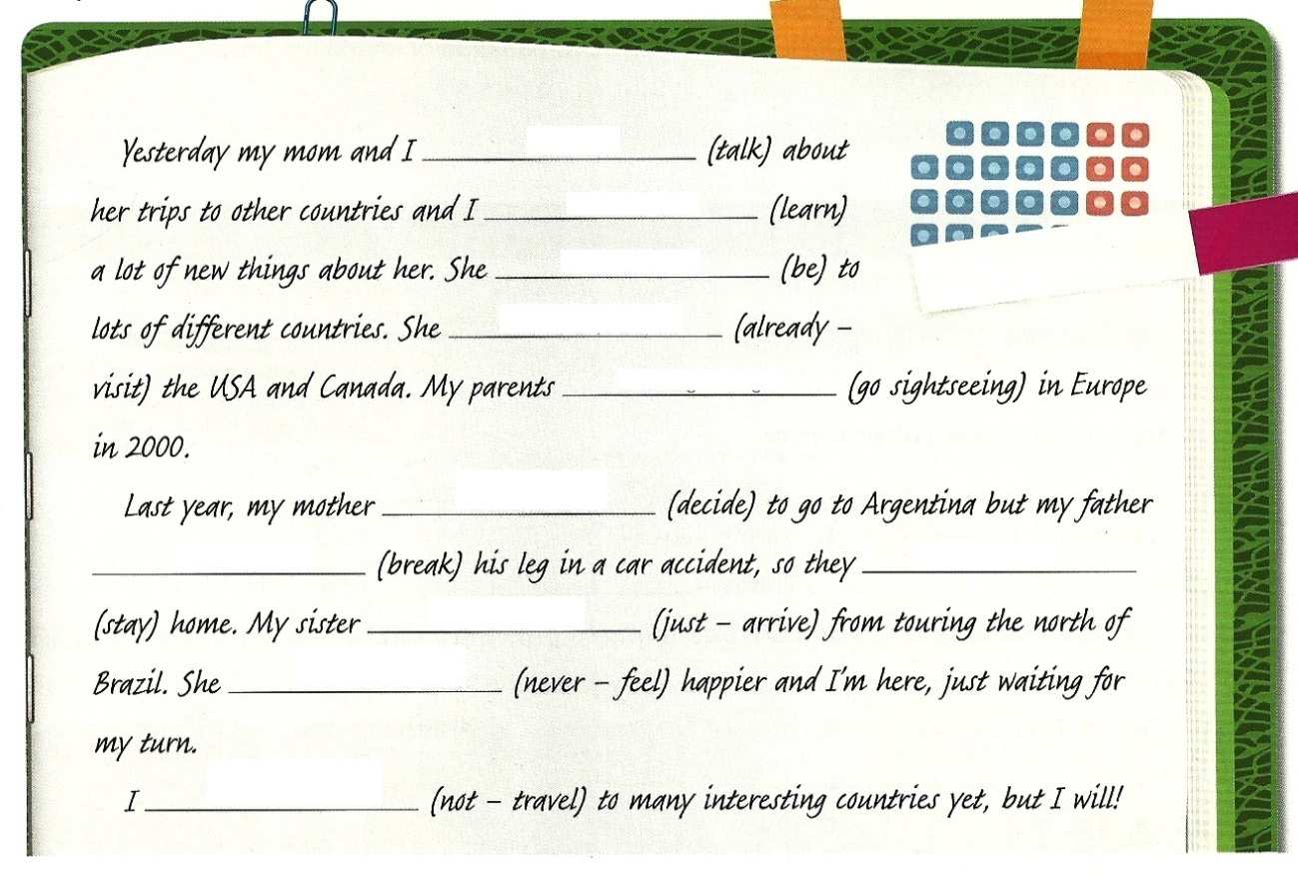
49. Underline the correct alternatives. Simple Past or Present Perfect?
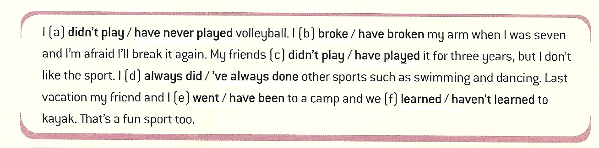
50. Complete the sentences using SIMPLE PAST or PRESENT PERFECT. 