Coc recup.7º

- How many... ?( quantos) : usado para substantivos contáveis.
- How much...? ( quanto ): : usado para substantivos incontáveis.

1. Use How many or How much.
a) _________________money do you need?
c) ________________water do you want?
b) _________________books are there?
d) _______________eggs are there in the fridge ?

2. Write in Portuguese about: ( Escreva em Português sobre : )
a) Uncountable Nouns :____________________________________________
_______________________________________________________________
b) Countable Nouns:______________________________________________
_______________________________________________________________
3. Write ( U ) to uncountable nouns and ( C ) to countable nouns.
( ) egg ( ) ice cream ( ) milk ( ) rice ( )cookie

( ) juice ( ) apple ( ) orange ( ) pizza ( ) bread

4. Complete the sentences with To be in the Simple Past.
a) He ___________a plumber.
b) The boys__________alone.
c) Martha____________ happy.
d) My father ________at work.
e) We _________at the party.

5. Complete the sentences with was or were.
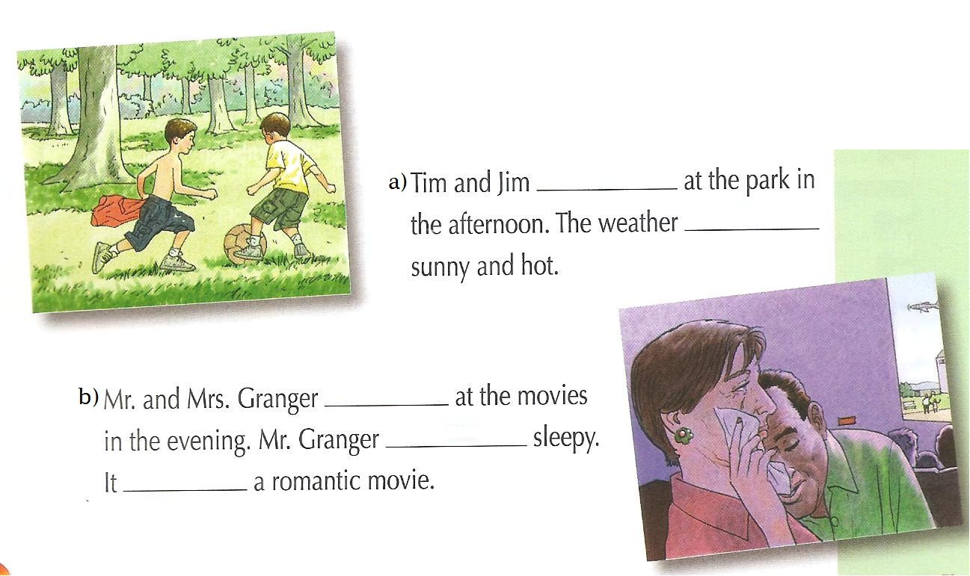
6. Write ( C ) to correct sentence and ( I ) to incorrect sentence.

( ) I were at home at night.
( ) Sheila and John were at school.
( ) Was she absent yesterday?
( ) You not were alone.
( ) My brother were at the library.

7. Mark the correct option.
- Jordan and I_________at the party.
a) was
b) were
c) am
d) is

8. Rewrite the sentences in the short form.

a) She was not sad.________________________________________
b) You were not alone_____________________________________

9 . Mark an X in the right sentences.( Marque um X nas frases certas)

a) Peter and John was happy.
b)They was at home.
c) Susan was tired yesterday.
d) The boys were playing soccer.

10. Rewrite the sentences in the short form.

a) She was not sad.________________________________________
b) You were not alone_____________________________________

11. Complete with the Simple Past of the verb TO BE.

Yesterday it____________very hot.The Smiths____________in their farm. Ronald__________in the lake and his sister and mom__________in the pool.His father_____________in the barn. Their dog ____________near the lake.They__________

12. Correct the mistakes.
( Corrija os erros)

a) I were at home at night. ___________________________________________
b) Sheila and John was at school. _____________________________________
c) She was absent yesterday? _________________________________________
d) You not were alone._______________________________________________
e) My brother were at the library. ______________________________________

13. Complete the chart.
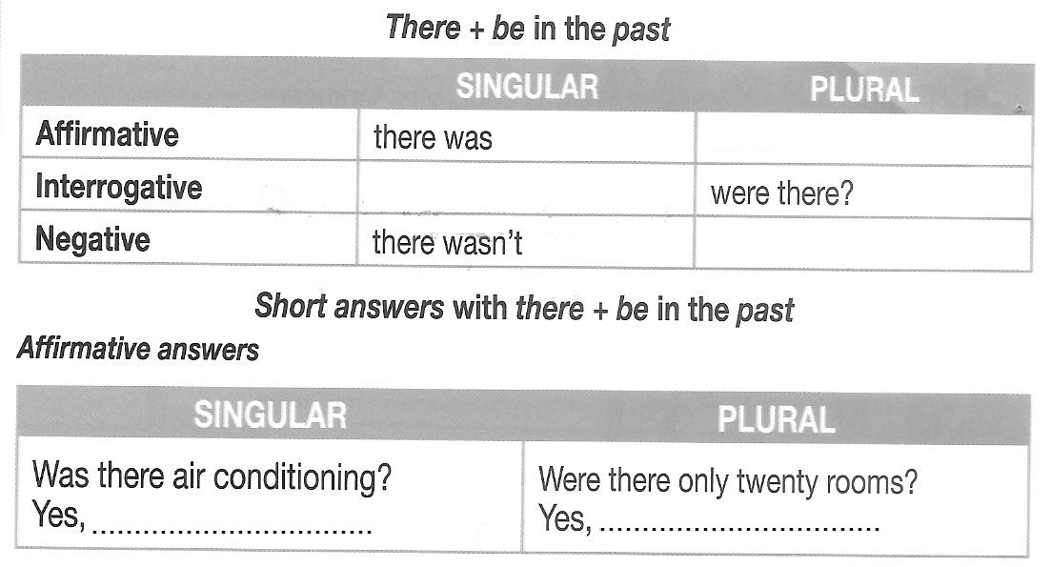
14. Complete the sentences with the correct alternative.

At the school ________________ many strange creatures. ___________________a strange ghost. His name ________ Nearly- Headless.

- there were – There were - were
- there was – There was – was
- there were – There was – was
- there was – There was – were

15. Write ( C ) to correct sentences and ( I ) to incorrect sentences.
( ) There were a cat in my yard.
( ) There was boys at the club.
( ) There were hats on the table.
( ) There were children in my room.
( ) There was a man at the bank.

16. Use There was or There were.
a) ________________one cat in the garden.
b) ________________ a book on the desk.
c) ________________ peaches in the basket.
d) ________________ five girls in the room.

17. Mark the correct alternative.
- ______________ two banks near here.

a) there is b) are there c) there are d) is there

- ______________ a park in London.

a) there is b) are there c) there are d) is there

- . ______________ five books on the desk?

a) there is b) are there c) there are d) is there

- .______________ one pencil on the sofa.

a) there is b) are there c) there are d) is there

- ______________ two shopping centers in Imperatriz.

a) There is b) are there c) there are d) is there

18. Use There was or There were.
a) ___________________ three bags on the sofa.
b) __________________ a shopping in Imperatriz.

19 . Rewrite the sentences.
a) There was a flower in the garden.
Int.:_____________________________________________
Neg.:____________________________________________

20. A forma interrogativa da frase : There were apples in the basket é :
a) There were apples in the basket? b) Are there apples in the basket?
c) Were there apples in the basket? d) There are apples in the basket?
21. Translate these sentences in Portuguese. ( Traduzir as frases em Português )

a) John can swim._______________________________________________
b) I can’t play soccer.____________________________________________
c) They can speak Russian.________________________________________
d) Kelly cannot ride a horse.________________________________________

22. Give short answers. ( Dê respostas curtas )

a) Can she draw flowers? b) Can you swim ? c) Can Fred ride a bike?
Yes,_____________ Yes,_________ Yes,__________
No,_____________ No,_________ No,___________

d) Can they play chess? e) Can Carol sing?
Yes,____________ Yes,____________
No,____________ No,____________
23. Rewrite the sentences.
a) Jessie can swim.
Int.: ______________________________
b) We can speak Japanese.
Int.:_______________________________
24. . Rewrite the sentences.
a) They can ride a bike.
Neg.:_______________________________

b) Mary can speak French.
Neg.:_______________________________

25. Read the following text.

Hello. My name’s Júlio and I live in Fortaleza. It’s very hot here. I’m into surfing and skating, but I don’t like shopping. My sister, Helena, can’t surf , but she can skate a little. She can also dance very well.

Complete the sentences with information from the text.

- Helena can______________and________________.
- Júlio can______________and__________________.
- Júlio and Helena are from____________________. ( from = de )
- Júlio don’t like___________________.

26. Look at the picture and give short answers.

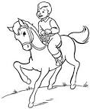
a) Can Lucca ride a horse? b) Can he ski?
__________________ _________________

27. Write sentences with the verb can. Follow the example.
( Escreva frases usnado o verbo Can.)

a) I / play the guitar. I can play the guitar.

b) You /cook dinner / ? . __________________________________________

c) I / ( not ) dance / . ______________________________________________

d) Mr. Miller / drive a bus /. ________________________________________

e) Carla / ride a bike / . _____________________________________________

28.The sentence “ Elas sabem dançar Jazz” in English:
- He can dance jazz.
- They can’t dance jazz.
- Can she dance jazz?
- They can dance jazz.

29. Mark the correct sentence.
a) She dance can hip hop.
b) They can’t not swim.
c) I can speak English.
d) He can ride a horse?
30. Look at the pictures and write sentences using can or can’t. Follow the example
play the piano dance swim sing ride a bike

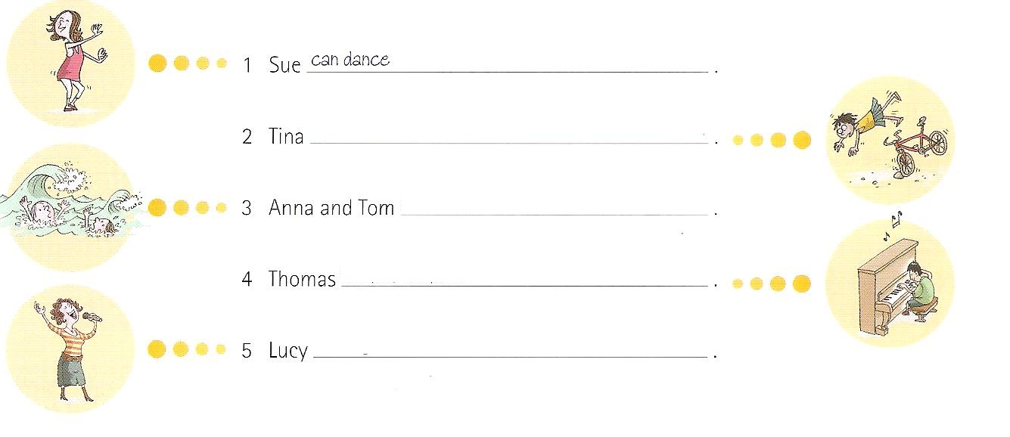

Simple Past Tense

Affirm.: Sujeito + verbo no passado

31. Complete the sentences with the Simple past.
a) Flávia ________________ to Paris last month. ( go )
b) They___________________flute . ( play )
c) Mohana_________________an iphone 5 last month. ( buy )
d) I ___________________a good film yesterday. ( watch )
e) She ______________a ring. ( find )
f) Mércia got________________last Saturday. ( marry )

32. Rewrite sentences.

Interrogative: Did + sujeito+ verbo no infinitivo ( normal )

a) Isabela opened a new restaurant last week.
int.:_______________________________________________________
b) She sent an e-mail to her mother last night.
Int.:________________________________________________________
c) You saw an accident yesterday.
int.:________________________________________________________

d) He studied math yesterday.
Int.:________________________________________________________

33. Rewrite the sentences.

Negative : Sujeito + did + not + verbo no infinitivo ( normal )

a) Julio arrived late at home.
Neg.:_________________________________________________________

b) They met their friends last night.
Neg.:_________________________________________________________

c) The girls went to the party last weekend.
Neg.:_________________________________________________________

d) My mother prepared a delicious cake last Sunday.
Neg.:_________________________________________________________

34. Use short answers.
a) Did he play chess ? b) Did Lorena buy a new schoolbag?
__________________ ______________________
__________________ ______________________

c) Did you close the window? d) Did they take the bus?
__________________ _____________________
__________________ __________________
35. Vocabulary :
- yesterday__________________________
- last Sunday________________________
- years ago__________________________
- last week__________________________
- last weekend ______________________
- last month_________________________
- last year___________________________
36. Correct the mistakes .

1. Anny go to the club last Sunday. ( go)
___________________________________________________________
2. She did buy a car yesterday? ( buy )
___________________________________________________________
3. Did they played tennis last night ? ( play )
____________________________________________________________
4. Betty drink milk yesterday. ( drink)
____________________________________________________________
5. They speaked two languages. ( speak )
_____________________________________________________________

37. Write in English.
1. Lara viajou para Fortaleza anos atrás.
____________________________________________________________
2. Você foi para a escola sábado passado?
____________________________________________________________
3. Eu comi pizza semana passada.
____________________________________________________________
4. Minha mãe não fechou a porta.
____________________________________________________________
5. Nós assistimos TV ontem.
____________________________________________________________
38. Put the sentences in the correct order.
a) ? / did / go / he / week / last / restaurant / to .
_________________________________________________________

b) They / travel / to / didn’t / yesterday / Italy.
_________________________________________________________
39. Mark the correct interrogative form .
a) They bought a car.
( ) Did they buy a car? ( ) They buy a car? ( ) Did they bought a car?

b) She played the piano.
( ) She played cards? ( ) Did she play cards? ( ) Did she played cards?

40. Mark the correct option.
- She _________________volleyball last week.
( ) play ( ) played ( ) plaied

- Did you______________English last night?
( ) study ( ) studied ( ) studied
41. Regular Verbs

Simple past Translation

- to plan _______________ __________________
- to stay _______________ __________________
- to watch _______________ __________________
- to visit _______________ __________________
- to open _______________ __________________
- to start _______________ __________________
- to close _______________ __________________
- to study _______________ __________________
- to listen _______________ __________________
- to travel _______________ __________________
- to marry _______________ __________________
- to prepare _______________ __________________
- to play _______________ __________________
- to arrive ________________ __________________
- to wash ________________ __________________

42. Irregular Verbs

Simple past translation
- to be _______________ ________________
- to go _______________ ________________
- to drink _______________ ________________
- to read ________________ ________________
- to eat ________________ ________________
- to see ________________ ________________
- to buy ________________ ________________
- to meet ________________ ________________
- to have ________________ ________________
- to speak _________________ ________________
- to teach ________________ ________________
- to send ________________ ________________
- to take ________________ ________________
- to wake ________________ _________________
- to find _________________ _________________

43.Mark the correct alternative.( marque uma alternativa para cada opção)

a) Regular verbs: b) Irregular verbs:
( ) clean; have; stay ( ) eat; give; see
( ) want; stay; play ( ) use; go; close
( ) go ; watch; visit ( ) look; feed ;see

44. Mark the correct option to interrogative form.
( Marque a forma interrogativa correta para as frases abaixo)

a) You closed the window b) They went to the zoo yesterday.
( ) Did you closed the window? ( ) They go to the zoo yesterday?
( ) you closed the window? ( ) Did they went to the zoo yesterday?
( ) Did you close the window? ( ) Did they go to the zoo yesterday?

45. Write ( R ) to Regular verb and ( I ) to Irregular verb.
( ) be ( ) drive ( ) brush ( ) want
( ) play ( ) go ( ) have ( ) close

46. Mark the correct short answer.
a)Did they read a book ? b) Did you drink a milkshake?
( ) Yes, they did. ( ) Yes, you did.
( ) Yes, he did. ( ) No, I didn’t.

c) Did Mary buy a car? d) Did the boys go to the club?
( ) Yes , she did. ( ) yes, the boys did.
( ) No, she did. ( ) yes, they did.

47. Match the columns.
( 1 ) years ago ( ) mês passado
( 2 ) yesterday ( ) anos atrás
( 3 ) last week ( ) fim de semana
( 4 ) last month ( ) semana passada
( 5 ) weekend ( ) ontem

48. Write ( C ) to correct sentences and ( I ) to incorrect sentences .
a) ( ) Did they played soccer?
b) ( ) Susan work a lot yesterday.
c) ( ) Meg read a book last night.
d) ( ) Miss Taylor teached Spanish last year.

49. Choose the correct answer.
- The boy met his friend last week.
( ) O garoto encontra seu amigo toda semana.
( ) O garoto encontrou seu amigo semana passada.
( ) O garoto tem encontrado seu amigo a semana toda.

- Did John go to London last year?
( ) John vai para Londres no próximo ano?
( ) John foi para Londres ano passado?
( ) John foi para Londres semana passada?

50. The Simple Past of the verbs:
1. To leave :
a) left b) leaved c) lefted

2. To begin :
a) begin b) began c) begined

3. To see:
a) see b) saw c) seen

4. To drive:
a) drave b) drived c) drove

